
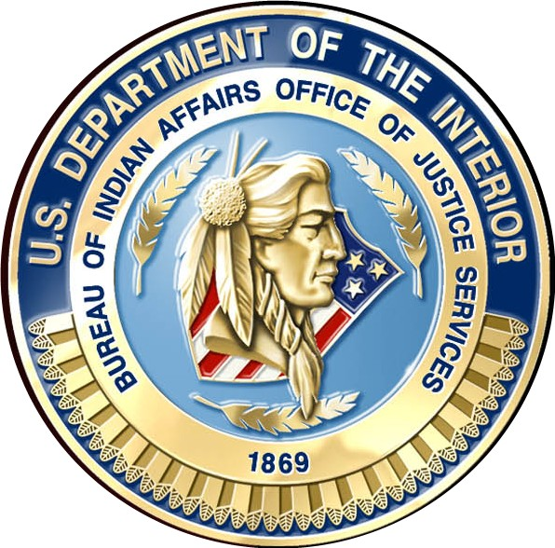
United States Department of the Interior

Bureau of Indian Affairs

Office of Justice Services
Turtle Mountain Agency
P.O. Box 1436
Belcourt, North Dakota 58316

Reply to:
Law Enforcement Services
701-477-6134

June 30, 2009

Mr. Richard Marcellais
Tribal Chairman
Turtle Mountain Band of Chippewa Indians
P.O. Box 900
Belcourt, North Dakota 58316

Chairman Marcellais:

Per your request, I am writing you this letter with information regarding the Dakota Peacekeeper Operation that the BIA law enforcement conducted last year starting in June 2, 2008 at the Standing Rock Agency, Fort Yates, N.D. This was a surge of approximately 20 BIA or Commissioned Tribal Police Officers that were sworn in and to up hold the laws at the Standing Rock Sioux Reservation, both South Dakota and North Dakota sides of the reservation.

I was the Assistant Special Agent in Charge at the time for BIA Law Enforcement working out of the District I Office, Aberdeen, S.D. My immediate supervisor was Elmer Four Dance, who is still the Special Agent in Charge, District I Office. I was working on behalf of Mr. Four Dance.

I set up the Command Post for the surge into Standing Rock. I supervised an additional 20 police officers and we rotated shifts, working with the existing law enforcement there. In the first 9 weeks, which I was part of, I attended 16 community meetings and listened to the concerns of all citizens that attended. During this time, I kept stats of arrest made and which officer and what violation was charged to the subjects. We had 1164 arrest in the first 9 weeks.

The people started to relax and stated that they felt safe. Elders came to meeting in the second month and stated that for the first time in many years, they could sleep with the residence windows open and feel safe.

You wanted some Pros and Cons of this operation. I would say that nothing but good came from this.

My opinion of negative issues first:

- Law enforcement personnel had to come from other stressed agencies.
- Perspective of the people, when the surge leaves, everything back to normal on reservation.
- The large funding issue to run this operation.
- Other tribes upset, why they couldn’t bet the same treatment.
- With large amount of arrest, tribal judge and court staff had a hard time to keep up.
- Funding for the courts also needed to be increased.
- Courts were held even on Saturday and Sundays.

These issues are minor to the positive outlook that came to ALL INDIAN COUNTRY LAW ENFORCEMENT:

My opinion of Positive issues:

- The Standing Rock Sioux Tribe lobbied hard for over three years of shortage in law enforcement personnel and budget. They received an increase in both after the surge.
- With more personnel available, it showed that stepping up law enforcement can change a positive outlook for the community.
- I saw community policing at its finest when officers had time to attend meetings, pow-wows, school functions, GREAT/DARE training at the boys and girls clubs, community events in the park and much more.
- Complaints were answered on a more timely response with more coverage in a large land mass, which is well over 1.4 million acres with 12 city communities.
- Funding was increased and monies found after many meetings with the South Dakota and North Dakota Senators.
- This also increased small amounts of funding for all Indian Country law enforcement throughout the United States.
- Law and Order was at its finest with many arrest made and the community felt safe.
- With meetings, city police departments and the two county sheriff’s departments came aboard and agreed to visit a Memorandum of Agreement and Deputation Agreement with the Tribe, BIA and local Sheriff and City Police Departments.

This surge into Standing Rock was one of the most important and smartest moves I have ever seen in law enforcement and I totally agree that it brought positive moral to Indian Country. I know it would not be cost effective to conduct such surges at all reservations, but if anything, I hope it showed people, congress and other entities that law enforcement in Indian Country, in some areas, is under staffed and under budgeted, but with more influence, law enforcement can be a professional and have a positive impact in our communities.

Mr. Chairman, if you need anything else or need to contact me, please call my cell phone at (701) 550-0335.

_______________________
Gerald A. Medrud
BIA/Chief of Police

