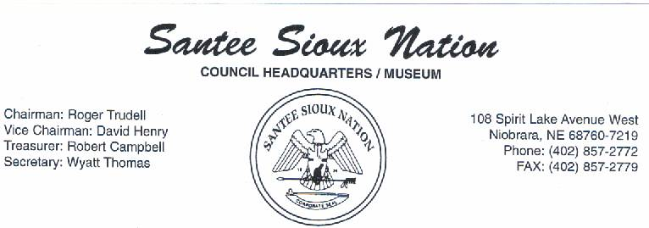

October 29, 2007

Testimony on compensation for lands taken for the construction of Gavins Point Dam and Lewis and Clark Lake

Presented to The Honorable Senator Byron Dorgan, Chairman, and Members of the Senate Committee on Indian Affairs.

Presented by:

Roger Trudell, Chairman
Santee Sioux Nation

Thank you Honorable Chairman and Members of the Committee for giving the Santee Sioux Nation the opportunity to provide testimony on the justness or the lack thereof for compensation on lands taken for the construction of Gavins Point Dam and Lewis and Clark Lake.

First, let me inform the Honorable Chairman and members of this committee the Santee Sioux Nation is grateful for what compensations have been provided. I realize a formula was developed based on a number of factors to arrive at the sum of four million plus dollars to be held essentially in escrow for the Santee Sioux Nation generating interest for use by the Santee Sioux Nation based on a spending plan developed through public meetings and with the approval of the Bureau of Indian Affairs.

Due to the fact that we lack resources to avail ourselves of legal and economic expertise to show in dollars past lost revenues or the inability to show generation of revenues due to the loss of access to the river. I will do my best to provide what information I can.

For the last fifty years former Santee Sioux Nation property has been a Mecca for the river sports man. Waterfowl hunters and sports fishermen annually come to our community and reservation to practice their sports. Over the last fifty years permits and licenses have generated zero income for the Santee Sioux Nation. Yet the Santee Sioux Nation must stand the repairs to our main thorough fare due to the wear and tear created by those very sportsmen who are paying other entities to enjoy their sport. Most recently we have had to leave the street in disrepair because we lack the resources to make repairs.

Should the Tribe have had control of the river and the primary access points there would have been the potential to develop the tourist trade not only with the hunters and fishermen, but with the recreational river users. That factor was not part of the formula. One could only project and estimate what the potential income to the Tribe could have been. Unfortunately not being an economist, I can not make that projection.

A greater factor that was not considered in the formula is the advanced siltation of the Lewis and Clark Lake which is devastating to our existing land base. The siltation is creating a rising water table and eroding tribal lands along the creek and stream beds. The potential loss of revenues from those lands is not considered. The potential damage by the existing water table to individual wells and community wells will be costly. Individual wells are currently five thousand dollars or greater to get to untainted water. The municipal system purification process will have to be upgraded at a tremendous cost. Again, we lack the resources to provide these upgrades. A reservation wide drinking water system feasibility study was granted but under funded leaving the study somewhat in limbo.

Honorable Chairman, the compensation for the land taken may be just but the lack of compensation from lost revenues, ongoing repairs, and the further loss of lands need to be considered. The potential damage to our water system and individual wells need to be considered. Without consideration of these factors then I would state that compensation awarded is not just.

We request an additional period of time to provide supporting documentation.

Thank you for you consideration.

Respectfully submitted,

Roger Trudell, Chairman
Santee Sioux Nation.

