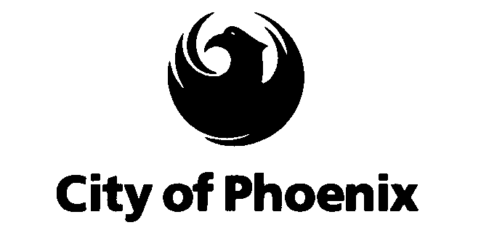

Statement of Phoenix Mayor Phil Gordon
U.S. Senate Committee of Indian Affairs
March 17, 2008

Background

Why is the Mayor of Phoenix testifying at a hearing devoted to Native American criminal justice issues?

Let me share a few facts.

Phoenix is the largest city in Arizona, a state with 22 tribes and several of the largest reservations in the country. We are the financial, legal, governmental, and economic center for the state, and more specifically, Maricopa County, which has three recognized tribes, Slat River Pima-Maricopa Indian Community, Fort McDowell Yavapai Nation, and the Gila River Indian Community. In fact, we share 22 miles of our southern border with the Gila River Indian Community, one of the largest Indian communities in the state.

In addition, Phoenix has the third most Native Americans living within its boundaries of any U.S. city. Of the 10 largest U.S. cities, Phoenix has the highest percentage of Native American residents. That means we work closely with a variety of organizations, both tribal governments and community-based non-profit agencies, on issues as varied as cultural and archaeological preservation, affordable housing, transportation, and public safety.

One of my priorities as Mayor has been to facilitate regional action on a whole range of issues, including public safety. Crime and the criminals who commit crime know no boundaries. As a responsible City leader, it is imperative that I help foster cooperation among state, tribal, and municipal agencies so that we can make all our residents safer, whether they live in the City of Phoenix, on a tribal reservation, or in another part of the Valley.

Current coordination and collaboration between the City of Phoenix and local tribal governments

There are several areas of collaboration between the City of Phoenix and local tribal governments that may be of interest to the committee. For example, the Phoenix Police Department has several cooperative-use agreements in place with the Gila River Indian Community on a variety of issues. Specifically:
- We have an agreement spelled out in some detail in a police operations order on the protocol for dealing with fresh pursuits, apprehensions, and investigations that may occur between the City of Phoenix and Gila River.
- We have a cooperative-use agreement to share radio communications facilities and provide some microwave links for them for their public safety radio network.
- We have also provided radio equipment under a Department of Justice program that has facilitated better inter-operable communications, and our Phoenix Police personnel have met with Gila River staff to work on interoperable communications issues between the Phoenix South Mountain Police Precinct and Gila River.

In short, the Gila River Community Division of Public Safety has been a good partner with the City of Phoenix Police Department and we have been happy to work collaboratively to assist them with their public safety needs.

Also, we have reached out to Salt River Pima-Maricopa Indian Community and Fort McDowell Yavapai Nation on communications initiatives being led by the Phoenix Urban Areas Security Initiative, otherwise known as UASI, the Homeland Security Department initiative that supports the unique planning, equipment, training, and exercise needs of high-threat, high-density urban areas.

Although there are no specific agreements in place, Phoenix law enforcement has met with SRPMIC on several occasions and will be providing equipment for them to use for inter-operable communications in the region. We are working with them on the possibility of a long-term agreement to join our regional communications network. We look forward to continuing that effort and finalizing an agreement that will help protect all Salt River and Fort McDowell residents and residents throughout the Valley.

Proposals for improving cooperation between local law enforcement agencies and tribal agencies

We support a number of the concepts contained in the Committee’s white paper that is under discussion. Let me point to three specific areas that would be helpful to regional efforts to prevent crime and improve collaboration between local law enforcement agencies and tribal agencies.

- The facilitation of cross-deputation agreements between local police agencies and tribal law enforcement. We support a program within the Department of Justice to encourage and provide technical and other assistance to tribal, state, and local law enforcement agencies that have completed or are in the process of entering cooperative law enforcement agreements to combat crime on Indian lands.

- Increase federal support for hiring and training more tribal police officers. That doesn’t only help reservation residents, it helps the entire region by putting more boots on the ground who are available to investigate and fight crime across jurisdictional boundaries.

- As part of the reauthorization of the Indian Alcohol and Substance Abuse Act, include more programs for off-reservation treatment programs and youth assistance so agencies like Native American Connections and the Phoenix Indian Center can continue and expand their collaboration with tribes and their work to help tribal members who may have relocated to the urban centers and don’t have access to reservation based programs.

I appreciate the opportunity to share some of the success stories we have had working with Phoenix-area tribes, and encourage the Committee to continue its work to strengthen law enforcement collaboration among and between tribes and federal, state, and local governments.

