Testimony
of
Paula Clayton, M.D.
Medical Director of the American Foundation for Suicide Prevention
before the
Senate Committee on Indian Affairs
on
The Preventable Epidemic: Youth Suicides and the
Urgent Need for Mental Health Care Resources in Indian Country

March 25, 2010

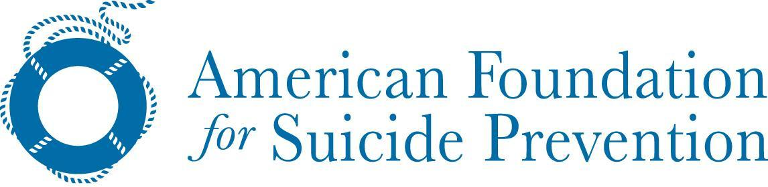

Good morning Chairman Dorgan, and Ranking member Barrasso, and members of the Committee. Thank you for inviting the American Foundation for Suicide Prevention (AFSP) to provide testimony on Youth Suicides and the Urgent Need for Mental Health Resources in Indian Country. My name is Paula Clayton. I am a physician. I currently serve as AFSP’s medical director. My responsibilities include overseeing and working closely with the AFSP’s scientific council to develop and implement directions, policies and programs in suicide prevention, education and research. I also supervise staff assigned to the research and education departments within AFSP.

Prior to joining AFSP I served as professor of psychiatry at the University of New Mexico School of Medicine in Albuquerque. I also currently serve as professor of psychiatry, Emeritus, for the University of Minnesota, where I was a professor and head of the psychiatry department for nearly twenty years. My research on bipolar disorder, major depression and bereavement allow me to understand some of the antecedents of suicide and to appreciate medical research and public/professional education programs aimed at preventing it.
AFSP is the leading national not-for-profit organization exclusively dedicated to understanding and preventing suicide through research, education and advocacy, and to reaching out to people with mental disorders and those impacted by suicide. You can see us at www.asfp.org.
To fully achieve our mission, AFSP engages in the following Five Core Strategies, (1) Funds scientific research, (2) Offers educational programs for professionals, (3) Educates the public about mood disorders and suicide prevention, (4) Promotes policies and legislation that impact suicide and prevention, (5) Provides programs and resources for survivors of suicide loss and people at risk, and involves them in the work of the Foundation.
I have provided the committee staff with a Power Point presentation I recently delivered here in Washington, DC on March 8, 2010, entitled, “Suicide Prevention – Saving Lives One Community at a Time.” I also included a copy of AFSP’s 2010 Facts and Figures on Suicide. Both documents will provide Committee members and their staff an overview on the issues associated with suicide in America today, along with some examples of programs and services to prevent this major public health problem.

Suicide is the 11th leading cause of death in the United States and the third leading cause of death in teens and young adults from ages 15 - 24. The suicide rate in this younger group is about 9/100,000. In one study of a well monitored tribe the rate was 128.5/100,000 or more than 13 times that of all other US young people. In this single tribe there were 25 deaths in one year. Monitoring of suicide attempts and suicide is an essential first step.

Suicide is the result of unrecognized and untreated mental disorders. In more than 120 studies of a series of completed suicides, at least 90% of the individuals involved were suffering from a mental illness at the time of their deaths. The most common is major depression, followed by alcohol abuse and drug abuse, but almost all of the psychiatric disorders have high suicide rates.

So, the major risk factors for suicide are the presence of an untreated psychiatric disorder, the history of a past suicide attempt and a family history of suicide or suicide attempts. The most important interventions are recognizing and treating these disorders. Every culture has strong biases against doing that. These must be identified and overcome.

One such effort to present youth suicide to the general population is two films AFSP developed. The first is about depression and is for teens and the second is a companion film to help teachers recognize the mental illnesses in teens that may lead to suicide. Both deal with recognition and referral. The first depicts four teens with different types of depression who are referred for treatment by four different people (parent, peers and a guidance counselor, the kid himself and a primary care physician). The package is currently being used in more than 1000 schools across the country and has recently been adopted by the State of Alabama to show in every high school in the state. A similar film could and should be made for and about Native American teens. Although such films need clinicians and a filmmaker who are culturally sensitive, the messages should be the same: depression is a medical illness, it is not your fault, it is OK to seek help and treatments can make you well.

A second approach being used in the general population is screening for early detection and referral. An approach best exemplified by Teen Screen. For young adults AFSP has an anonymous online screening program that is evidenced based and approved for use by the Suicide Prevention Resource Center. It involves having a counselor available to respond quickly to an email questionnaire that the troubled young person submits to engage them in a dialogue in order to finally convince the person to come for an evaluation. It is proven to engage young people who are not known to the health system.

A third, but extremely important aspect to suicide prevention is to train nurses, other health personnel and primary care physicians to recognize disturbed kids and begin treatment. I would think this should entail getting the entire tribe or pueblo involved in the endeavor. There are many public health models of paraprofessionals being the first source of recognition. Those young people who do not respond to initial treatments need to be referred to mental health and substance abuse specialists. The referral process needs to be clear and simple. The substance abuse treatment should also start with self help groups on the reservations. There are proven short term psychotherapy interventions for suicide attempters and for people with depression in the general population. Money needs to be invested to develop such therapies for Native Americans.

Finally, AFSP believes that suicide postvention behavior is important in suicide prevention, so we have multiple ways to improve this aspect of care. AFSP has already done two suicide support group training programs in South Dakota that included Native American participants. AFSP is writing postvention instructions for middle and high school personel to guide them in their plans in the aftermath of a suicide. AFSP’s website contains many other resources that those who have lost someone to suicide can review and use or modify.

Chairman Dorgan, Ranking member Barrasso, suicide in Native American youth is rising and is an absolute crisis. Depression can be fatal. Excessive drinking or drug use can be fatal. The fatality is mainly by suicide. Culturally sensitive but sustained efforts with multiple approaches offer our best hope to get students into treatments. Obviously, if there is a shortage of treatment resources, than dollars need to be allocated to develop innovative new treatments for Native American youths. We must reduce this fatal outcome. The American Foundation for Suicide Prevention is ready and willing to offer our expertise and advice to this Committee and to all members of Congress as you make the important decisions on how to reduce suicide in the Indian nations.

I will be happy to answer any questions you and your colleagues might have. Thank you.

