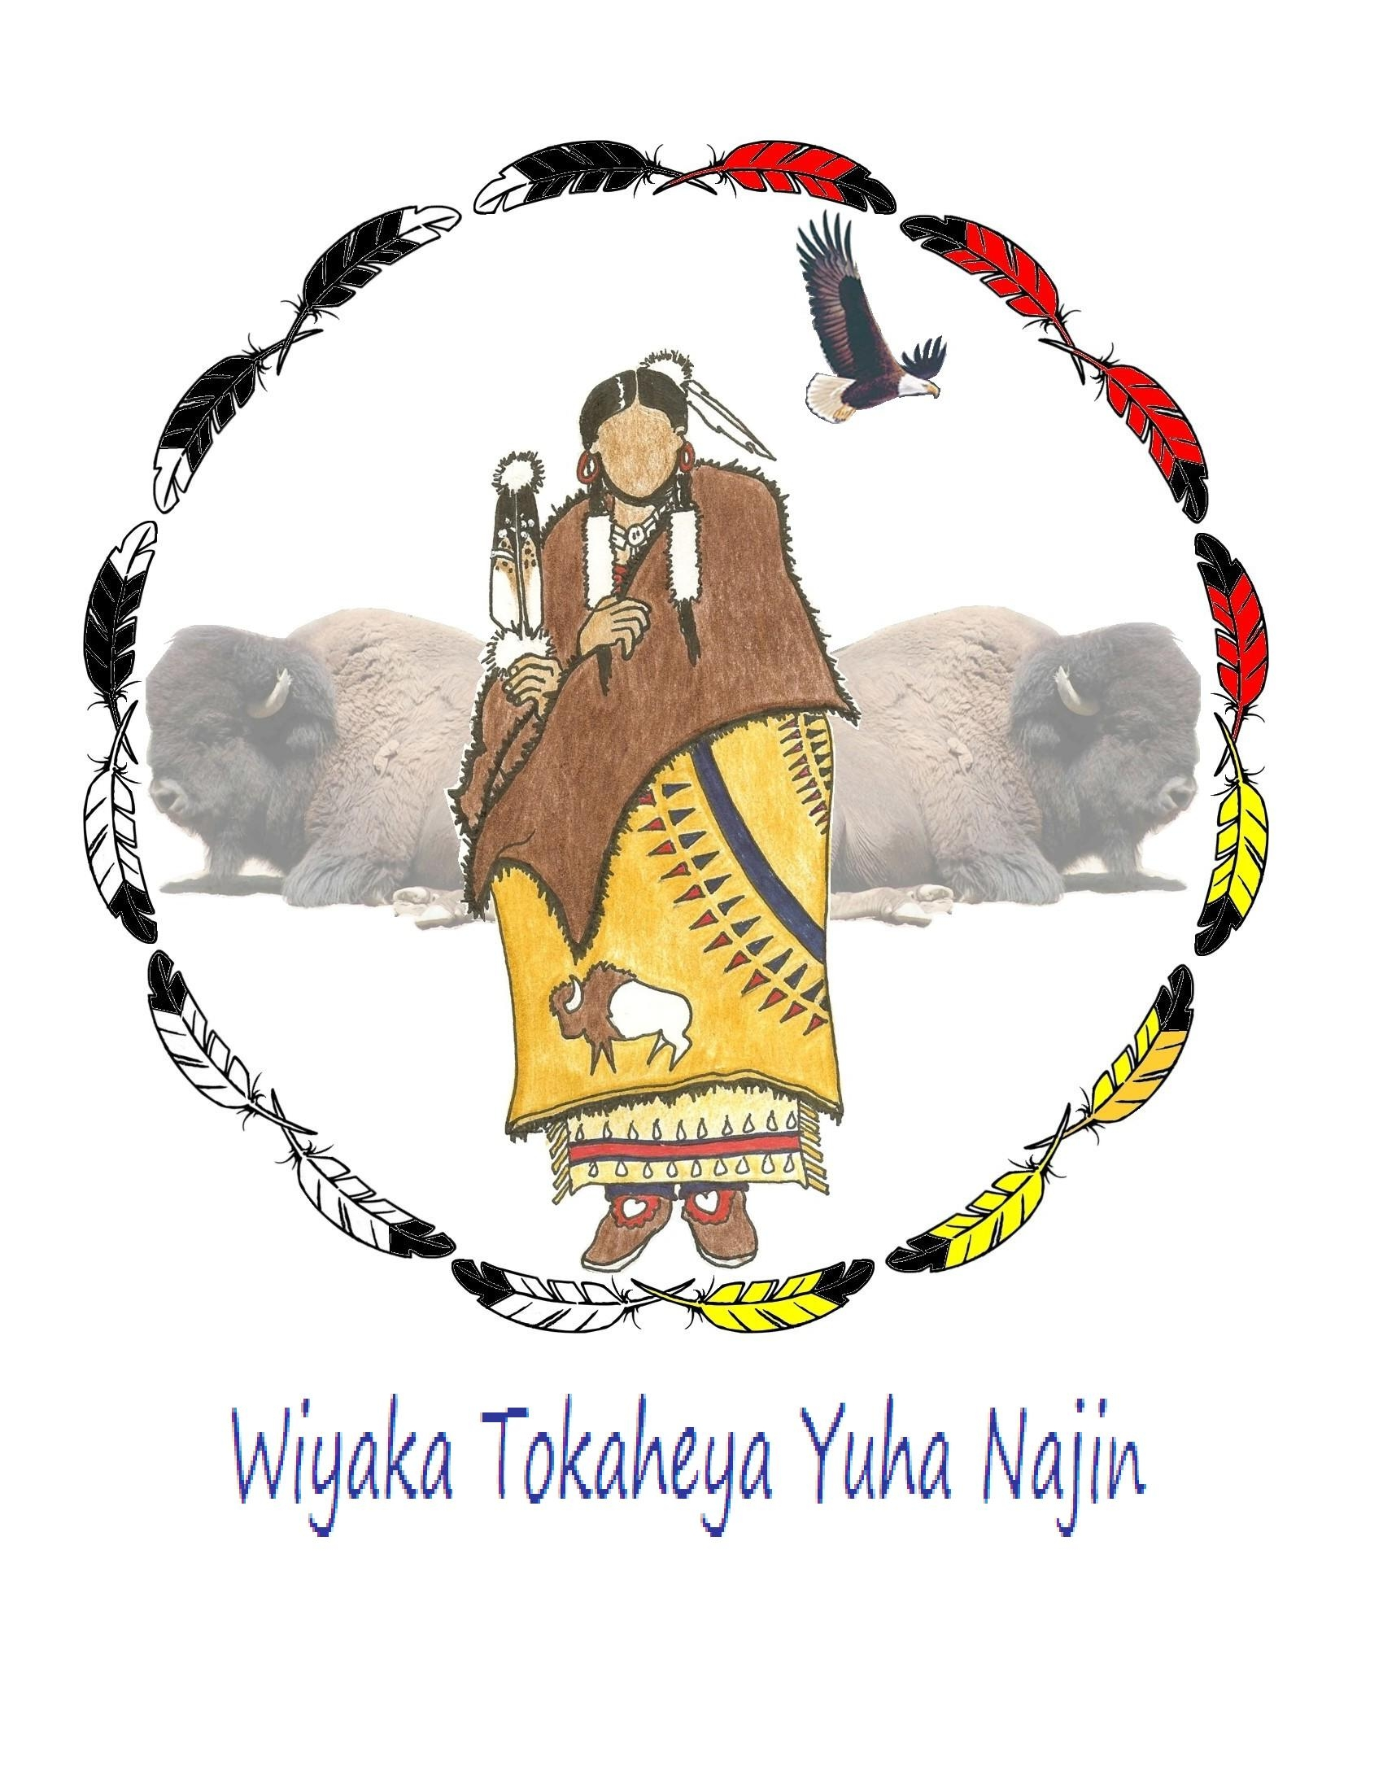
Oglala Sioux Tribe
PINE RIDGE INDIAN RESERVATION
POST OFFICE BOX #2070
PINE RIDGE, SOUTH DAKOTA ~57770~

Testimony of Hermis John Mousseau
Oglala Sioux Tribe
July 30, 2009

Good Afternoon Mr. Chairman and Members of the Committee:

My name is Hermis John Mousseau and I am a member of the Oglala Sioux Tribal Council. I am also the Chairman of our Tribal Judiciary Committee, a former Oglala Sioux Tribal Police Officer and a former Oglala Chief of Police. Thank you for allowing me to present testimony on the gang problems which are today endangering lives in my tribal community.

Mr. Chairman, this issue is very personal for me because in 2003 I was wounded in the line of duty by a tribal gang member when I was called to address a domestic disturbance. During that incident, I was forced to shoot that individual and memories like that stay with you forever.

Violent crime is increasing on our reservation every day. Just this past weekend, we had a stabbing, a shooting, and a person brutally attacked by a gang member. A week before that, on July 12th, one of our female officers was brutally attacked by a gang member when she attempted to arrest him, and she was forced to shoot that individual in order to save her own life. Now we have blogs, gang tags and open talk in our gang communities threatening the life of that officer and she and her immediate family have had to go into hiding. This same female officer had her arm broken a year before when she attempted to arrest another known gang member for another domestic disturbance and that heroic officer has gone through all of this for a salary of about $35,000 a year with no health benefits and no police retirement.

While our police department lacks the resources necessary to track all gang-related activity on our reservation, we have identified at least 39 gangs operating in our community of 50,000, and we have logged 8,816 gang-related calls in FY 2008. That is up from the 7,721 gang-related calls that we were able to log in FY 2006. These calls range from simple assaults and burglaries, to life threatening fights and gun related charges. Each one of these calls endangers the officer who responds, and each one of these calls means that another member of our community has been a victim of some type of gang related activity.

We have included for your information a chart of our gang related offenses for calendar years 2006-2008. We have also included a youth survey which was done by one of our consultants in April and May of this year. The participants in that survey were 1137 students in our on-reservation schools. The results of that survey revealed that 55% of those students surveyed reported being a victim of gang related activity, 72% reported having been threatened personally by a gang or gang member, and only 65% reported that they felt safe from gang activity at school. Only 35% of those surveyed said that they felt safe from gang related activity in their own immediate community. So anyone that says that gang activity does not impact educational advancement is very wrong.

Gang activity started on our reservation because our young people were unhappy, powerless and bored. The joblessness and poverty on Pine Ridge has led far too many of our people towards alcohol and drugs, and because we have no adequately funded programs or residential treatment facilities to address this alcoholism and drug problem, we have a large number of minors who live in alcoholic families and simply do not want to go home. This coupled with our lack of after school programs, youth recreation centers and youth employment monies has left many of our young people receptive to gang life . For young people who have never had a $20 bill to spend, the promise of easy money for stealing a few items and selling a few drugs has been hard for many of our teenagers to resist. Now, we have families who have three generations of gang members in their homes.

Over time, as drugs have become more common, our gangs have become more brazen and fights over territory and drug sales has escalated. Today, we have gangs being formed just to protect their members from other gangs, and to allow their members to move freely across our reservation without fear of attack or intimidation. We also have gangs which were formed just to keep watch out for the police, so people could smoke a little dope and get drunk without the threat of arrest or attack from another gang.

In the past few years, we have seen more outside law breakers moving on to our reservation. It is not unusual to see a male Mexican national “falling in love” with one of our female tribal members and before long he is selling drugs out of her on-reservation home. Drugs are coming in every day from Minneapolis and Denver, and now from Omaha. Large urban based gangs such as Texas Syndicate, Indian Mafia, Native Mob, MS-13, and Surenios affiliated gangs now have members appearing on our reservation. To add to our fears, the Hells Angels biker gang has recently bought a bar in Scenic, South Dakota less than 20 miles away from our reservation border. Another biker gang affiliated with the Bandidos has been recruiting and they now have a base of operations in of Pine Ridge, South Dakota. Drug trafficking on the western side of our reservation relates mostly to marijuana and cocaine, but meth use is increasing every day. Because of the remoteness of our reservation, its centralized location in the United States, its jurisdictional complexities, and its lack of police manpower, we have become a prime target area for gang related crime and drug trafficking.

But here are most telling statistics: 50,000+ people, a land base the size of Rhode Island, 39 gangs and 12 police officers per shift- if no one is sick or on injured reserve. At Pine Ridge, we receive approximately 73,000 calls for police service each year. That is about 6,083 calls per month. We are forced to answer those calls with 48 police officers. Now 48 police officers divided by 4 shifts equates to 12 officers per shift. That means that each officer has to respond to 506 calls per month. That is not manageable for a police officer in an urban area where the call is a few blocks away, but it is impossible for us because most of our calls are 50 or 60 miles apart. As a result, we have a sizable number of calls that simply go unanswered and when our officers can respond, our response time generally runs around 1 hour, for even the most serious acts of violence. That means by the time we respond, the activity is generally over and the perpetrators have left the scene. The office responding would like to investigate what happened and arrest the people involved, but by that time he or she generally has another two or three calls backed up and has to leave to try to help someone else.

To make matters worse, all of our police officers have to work alone and backup is generally at least 40 minutes away. We have single officers walking alone into parties with 20 or more intoxicated or drugged out individuals, often with gang affiliations, or with a subject banishing a deadly weapon and they know going in that they are completely on their own.

Mr. Chairman, while we appreciate very much all that you are trying to do to increase the BIA law enforcement budget, I must respectfully tell you that it is simply not enough. Of the increase proposed in 2010, we at Pine Ridge are hearing that we will only get an increase of around $125,000, and while we appreciate that very much, $125,000 to address 8,816 or more incidents of gang violence, plus our 65,000 regular calls, does not go very far. It does not even give us one more officer per shift. Forgive me for speaking this bluntly, but the simple truth is we need more officers and we need them now! We have 5,000 gang members, but we also have 45,000 scared law abiding people whose lives I have sworn to protect. Please help me in anyway that you can to accomplish that goal.

We need more personnel to provide youth based prevention activities in and after school. And we need more investigators to review and investigate cases at the tribal level. We also need more officers to respond to these calls and merely to prevent the burnout of our current officers. Finally, we need more staff in internal affairs to ensure that our citizen complaints are handled in a timely manner.

I would like to ask our housing authority director, Mr. Paul Iron Cloud, to speak for just a bit about the impact that these gangs are having on the daily lives of our children, elders and families and our property.

Thank you again for this opportunity to speak to you about these very serious issues. I will be happy to answer any questions that you may have.

