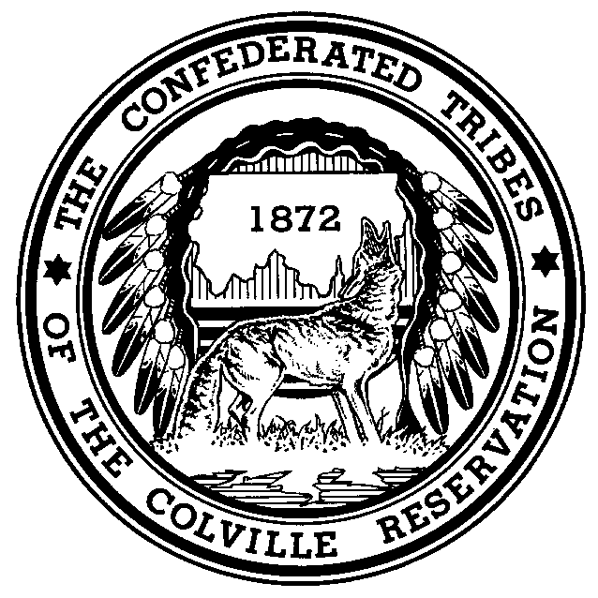
The Confederated Tribes of the Colville Reservation

Prepared Statement of the Honorable Michael Finley, Chairman
Confederated Tribes of the Colville Reservation

Senate Committee on Indian Affairs

Oversight Hearing on “The Indian Reorganization Act - 75 Years
Later: Renewing our Commitment to Restore Tribal Homelands
and Promote Self-Determination”

June 23, 2011

Good morning Chairman Akaka, Vice Chairman Barrasso, and members of the Committee. On behalf of the Confederated Tribes of the Colville Reservation (“Colville Tribes” or the “Tribes”), I would like to thank the Committee for convening this hearing on the Indian Reorganization Act of 1934 (“IRA”) and allowing me to testify. My name is Michael Finley and I am the Chairman of the Colville Tribes and am testifying today in that capacity. In addition, I also serve as the Chairman for the Intertribal Monitoring Association on Indian Trust, a national organization comprised of 65 federally recognized tribes from all regions of the country.

Today, I am pleased to share the Colville Tribes’ views and a bit of our history regarding the IRA. My remarks today will focus on the legacy that the Colville Tribes’ 1935 IRA election has left on the Colville Reservation, specifically as it relates to our land and law enforcement.

The Colville Tribes and the IRA

Although now considered a single Indian tribe, the Confederated Tribes of the Colville Reservation is, as the name states, a confederation of 12 aboriginal tribes and bands from all across eastern Washington State. The present-day Colville Reservation is located in north-central Washington State and was established by Executive Order in 1872. At that time, the Colville Reservation consisted of all lands within the United States bounded by the Columbia and Okanogan Rivers, roughly 3 million acres. In 1891, the 1.5 million acre North Half of the 1872 Reservation was opened to the public domain. The Colville Tribes and its members possess reserved hunting, fishing and gathering rights on the North Half.

The Colville Tribes rejected the IRA in an election held in April 1935, with 421 adult members voting in favor and 562 against. Peter Gunn, President of an organized group called the Colville Indian Association, protested to Commissioner of Indian Affairs John Collier that the local superintendent misled eligible Colville Indian voters into believing that the withheld votes would be counted as votes in favor of adopting the IRA. Despite the protest, no new election was held. The Spokane Tribe, which was also under the supervision of the same superintendant, perhaps not coincidentally also voted to reject the IRA. Colville Indians ultimately voted to approve a non-IRA constitution in February 1938. That constitution established the Colville Business Council, the 14 member body that governs the Colville Tribes today.

The Colville Tribes today has more than 9,400 enrolled members, making it one of the largest Indian tribes in the Northwest. About half of the Tribes’ members live on or near the Colville Reservation. Between the tribal government and the Tribes’ enterprise division, the Colville Tribes collectively account for more than 1,700 jobs and is one of the largest employers in north-central Washington State.

The 1935 IRA election at the Colville Agency had long-term impacts on the Colville Reservation, many of which continue to this day. As the Committee is aware, Section 18 of the IRA provides that none of the provisions of the IRA apply to any Indian tribe where a majority of adult Indians voted against its application. Regardless of the integrity of our 1935 election, the outcome of that election meant that the IRA did not apply to the Colville Reservation.

Checkerboarded Jurisdiction and Public Safety

According to our elders, it was the years immediately following the 1935 IRA election that much of the valuable land on the Colville Reservation—specifically those lands adjacent to lakes and rivers—passed into non-Indian hands. This is one of the most visible legacies of the Tribes’ rejection of the IRA because it has resulted in “checkerboarded” jurisdiction on many areas of the Colville Reservation.

The Colville Tribes possesses more trust land within its borders than many land-based Indian tribes, but this is only because the Colville Tribes has for the last several decades set aside funds from its own tribal timber sales to repurchase fee lands. Our checkerboarded areas today are near the more populated areas of the Reservation and in border communities. These also happen to be the areas where the Colville Tribes’ police force receive the majority of its calls.

The Colville Tribes have been fortunate to have been able to enter into cross-deputization agreements with the two counties on the Colville Reservation that mitigate the checkerboarding issues to a certain extent. The largest community on the Colville Reservation, Omak, has its own police force and the Colville Tribes does not have a cross-deputization agreement with that police department. The Tribes similarly does not have a cross-deputization agreement with the Coulee Dam Police Department, which is another populated border town on the Colville Reservation.

In absence of a fast and reliable way to ascertain title of the land prior to responding to a call, the Colville Tribes’ police force generally responds to all calls on the Colville Reservation out of an abundance of caution. The lack of cross-deputization agreements is most apparent when calls originate on fee land within these municipalities. Like many land based tribes, the Colville Tribes’ police force has a very small number of officers to patrol a large area. In our case, we occasionally have only a single officer to patrol the entire 1.4 million acre Colville Reservation. In circumstances where the Colville Tribes responds to calls where it is later determined that these municipalities actually possess jurisdiction, it would not be inaccurate to describe these situations as a diversion of tribal resources. Again, the continued alienation of tribal land following the 1935 IRA election at least contributed to this problem.

Loss of Protection of Tribal Lands

The legacy of the Colville Tribes’ 1935 IRA election is apparent in other areas besides mixed ownership of land within the Colville Reservation. The United States began construction on the Grand Coulee Dam in 1933, a massive project that would ultimately inundate thousands of acres of tribal land through the creation of its reservoir, Lake Roosevelt, and destroy the Tribes’ traditional fisheries forever. Historians have observed that without the structure of the IRA, the Colville Tribes (and the Spokane Tribe) was at a disadvantage when dealing with the United States when Reclamation began the project. Instead, the tribes were almost entirely dependent on the Office of Indian Affairs to look out for their interests as the project was developed.

To this day, the Colville Tribes continues to have jurisdictional disputes with state and local officials on areas within the Lake Roosevelt management area. Some of these disputes are attributable to checkerboarding, others to the creation and management of the Lake itself by federal officials. All them in some way can be traced to the 1935 Colville IRA election.

Another unfortunate legacy of the IRA was the loss of lands in the North Half. Section 3 of the IRA authorized the Secretary of the Interior “to restore to tribal ownership the remaining surplus lands” that were formerly part of an Indian reservation but that had been open to disposal by the United States under any of its public land laws. For the Colville Tribes, this meant that our lands in the North Half generally remained unprotected from falling into non-Indian lands. Many of these lands had already been subject to claims under the 1872 Mining Act. Although the Secretary of the Interior took steps to protect these lands and Congress ultimately took action in 1956, the outcome of the Tribes’ 1935 election complicated matters significantly.

Other Legacies of the IRA

For the Colville Indians and others that rejected the IRA, the ability to utilize certain IRA authorities remained in limbo for decades or, in some cases, still remain unclear. For example, it was not until passage of the Indian Land Consolidation Act in 1983 that Indian tribes that rejected the IRA were expressly allowed to have land taken into trust under Section 5 of the IRA, 25 U.S.C. § 465. Tribes that rejected the IRA would not be able to issue corporate charters under Section 17 of the IRA until passage of the 1990 amendments to the IRA. Although Congress has not explicitly addressed this issue, it was not until last year that the Department of the Interior reversed its prior position and concluded that the Secretary possessed the authority to proclaim reservations under Section 7 of the IRA for tribes that previously voted against it.

The Colville Tribes appreciates the Committee convening this hearing and is grateful to be able to share this history and perspective. At this time I would be happy to answer any questions that the Committee may have.

***

