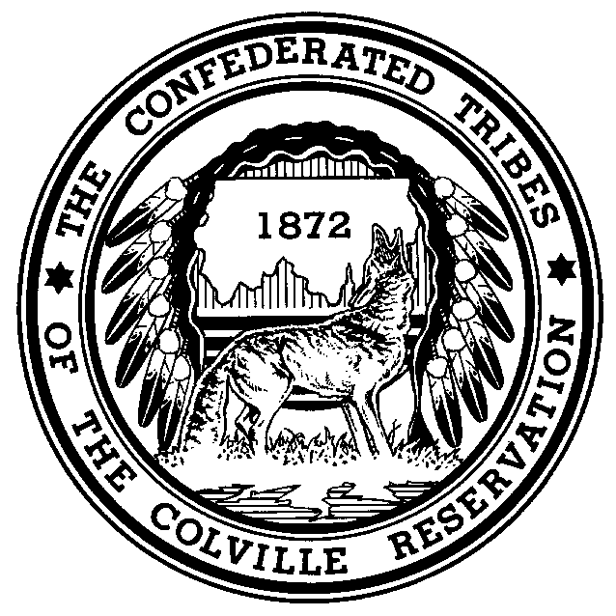
The Confederated Tribes of the Colville Reservation

Prepared Statement of Matt Haney, Chief of Police
Confederated Tribes of the Colville Reservation

United States Senate
Committee on Indian Affairs

Oversight Hearing to Examine Drug Smuggling and Gang Activity
in Indian Country

November 19, 2009

Good afternoon Chairman Dorgan, Vice Chairman Barrasso, and members of the Committee. My name is Matt Haney and I am the Chief of Police for the Confederated Tribes of the Colville Reservation (“Colville Tribe” or “Tribe”). I appreciate this opportunity to testify today on drug smuggling in Indian country. Specifically, I will discuss the Colville Tribe’s challenges in combating drug smuggling and cultivation on the Colville Reservation, provide examples of recent related incidents on the Colville Reservation, and provide recommendations on how the current situation can be improved.

Before I begin, I would like to thank the members of the Committee and the Committee staff for their work in reporting the Tribal Law and Order Act of 2009 for the full Senate’s consideration. As we have previously indicated, the Colville Tribe enthusiastically supports this important legislation and is grateful to the Chairman and Vice-Chairman for their willingness to consider and incorporate our suggestions into the version of the bill as reported.

The Confederated Tribes of the Colville Reservation

The Colville Indian Reservation encompasses approximately 2,275 square miles and is in north-central Washington State. Although now considered a single Indian tribe, the Confederated Tribes of the Colville Reservation is, as the name states, a confederation of 12 aboriginal tribes and bands from all across eastern Washington. The Colville Tribe has nearly 9,300 enrolled members, making it one of the largest Indian tribes in the Pacific Northwest. About half of the Tribe’s members live on or near the Colville Reservation.

Mexican Drug Trafficking Organizations

According to a National Drug Intelligence Center Report, Mexican Drug Trafficking Organizations (DTOs) are the most pervasive organizational threat to the United States. They
are active in every region of the country and dominate the illicit drug trade in every area except the Northeast. According to the U.S. Department of Justice’s National Drug Intelligence Center, DTOs operate in more than 20 cities in Washington State, including the cities of Spokane, Toppenish, and Yakima, and others near Indian reservations. The City of Seattle has reported that DTOs operating in that city have ties to the Tijuana drug cartel.

During the past three years, the Colville Tribal Police Department has identified at least 19 drug cultivation operations on the Colville Reservation and has seized more than 45,000 marijuana plants. The operations were located throughout the Colville Reservation in the Omak, Inchelium, Keller, and Nespelem communities. The plants had a street value of $1,000.00 per plant and collectively totaled $45 million. The majority of these operations appear to have ties to Mexican DTOs based on onsite investigations and intelligence. The Colville Tribe will provide the Committee with additional information for the record on these operations and other major drug busts on the Colville Reservation in recent years.

One case of particular interest was an outdoor marijuana operation in the Moses Meadow area of the Colville Reservation and a related growing operation in Sherman Pass, a heavily forested area adjacent to the Colville Reservation. Investigations into these operations were initiated in July 2007 after an Omak Police Officer obtained information from an individual who was aware of the operation and some of its participants. Surveillance efforts took place throughout July and August 2007. By using cellular telephone records, the Colville Tribal Police Department was able to identify the network of individuals involved and trace the upper level participants to Cutler, California.

When the arrest and eradication operations commenced on August 14, 2007 at the Moses Meadow grow location, two plant tenders were captured at the grow location itself. A search was also conduced at an Omak area home where a Mexican national was arrested. On August 15, 2007, two more plant tenders from the Moses Meadow grow operation were located and arrested. A total of 8,751 marijuana plants were eradicated at the Moses Meadow grow location.

The Moses Meadow growing operation was also connected through surveillance and cellular telephone records to a related operation located near Sherman Pass and, in turn, to the grow bosses in Cutler, California. The eradication of the Sherman Pass grow operation commenced on August 16, 2007 and resulted in the eradication of approximately 3,000 marijuana plants. Cellular telephone records indicated that the plan tenders had vacated the grow site before authorities arrived. The use of cellular telephones in such remote locations is notable because such communications typically require hill top calling locations or antenna boosting systems to facilitate the cellular telephones in otherwise low signal areas.

By the conclusion of these investigations, two of the three suspected grow bosses were taken into custody by federal authorities in Cutler, California. A total of seven individuals were arrested in these operations, all of whom were Mexican nationals, and a total of 10,751 marijuana plants were eradicated that had an estimated street value of more than $1 million. In addition to the Colville Tribal Police Department, these investigations involved a number of state, local, and federal law enforcement entities and required complex coordination, which demonstrates the challenges Indian tribes face in combating these types of operations on tribal land.

Airborne Drug Smuggling from Canada

In addition, the Colville Reservation has also experienced a significant amount of cross-border smuggling activity from Canada. Since 2006, numerous sightings of unmarked fixed-winged aircraft have been reported on or near the Colville Reservation. Most significantly, in March 2006, the Colville Tribe’s Natural Resources officers and officers from the Colville Tribal Police Department seized an unmarked float plane from Canada that was attempting to smuggle illegal drugs into the United States through the Colville Reservation. After being alerted to the plane, the officers were able to respond and disable the aircraft when it was attempting to take off from the Columbia River near the Grand Coulee Dam. After a long chase, the officers ultimately captured the pilot and handed over to federal law enforcement authorities an estimated $2 million in illegal drugs that had been deposited by the plane. The U.S. Border Patrol honored the tribal officers who participated in that seizure.

In addition to that widely publicized incident, the Colville Tribe’s law enforcement officers have apprehended or participated in the apprehension of several other individuals involved in cross-border smuggling activity. Collectively, these efforts have resulted in the seizure of millions of dollars in cash, marijuana, Ecstasy, cocaine, methamphetamines, and other illegal substances. These airborne smuggling incidents were highlighted in the 110th Congress in the deliberations that ultimately led to the inclusion of language in the Implementing Recommendations of the 9/11 Commission Act of 2007 that allows Indian tribes to access grant funding directly from the Department of Homeland Security.

The Colville Tribe continues to receive regular reports of unidentified aircraft on the Colville Reservation. Although the number of reports of unmarked aircraft has declined since 2006, the Colville Tribal Police Department continues to receive regular reports of plane sightings and remains very concerned about cross-border smuggling activity and other vulnerabilities on the Colville Reservation. In response to the airborne smuggling events that began in 2006, the U.S. Attorney for the Eastern District of Washington was quoted in a northwest newspaper as noting that, “a person that will smuggle guns, drugs, meth, Ecstasy and cash will also be the kind of person who will smuggle a special interest alien or a terrorist.”

Resource and Logistical Challenges to Combating Drug Smuggling and Recommendations

Smugglers have found the Colville Reservation an attractive thoroughfare for smuggling activity because of its remote location and because of the limited personnel available to patrol such a large area. As the Committee is well aware, federal funding constraints severely limit the on the ground presence of the Tribe’s law enforcement officers. For example, today, the Colville Tribal Police Department has two officers scheduled for the day shift from 7:00 a.m. to 5:00 p.m. and three officers scheduled for the night shift from 5:00 p.m. to 3:00 a.m. Another officer works from 7:00 p.m. to 5:00 a.m., which means that this officer will be the only law enforcement officer on duty for the entire Colville Reservation tomorrow morning from 3:00 a.m. to 5:00 a.m. Although many land-based tribes have similar personnel challenges, the Colville Tribe has reason to believe that smugglers, particularly the airborne smugglers, exploit our lack of resources by monitoring our radio frequencies and coordinating their activities around our officers’ movements.

Another challenge to combating grow operations on the Colville Reservation is the scarcity of air support. Unless informants voluntarily provide information, the use of aircraft for flyovers is the only practical method of identifying grow operations. Currently, the Tribe has limited access to aircraft through the North Central Washington Narcotics Task Force which, in turn, receives its funding through the U.S. Department of Justice’s Edward Byrne Memorial Justice Assistance Grant Program. The Washington State Patrol, on occasion, allows the Tribe use of its air support as well. Allowing the Colville Tribe and similarly situated Indian tribes with a more formal mechanism to access air support would likely increase the effectiveness in eradicating grow operations.

Also, allowing Indian tribes such as the Colville Tribe access to the High Intensity Drug Trafficking Area (HIDTA) program would also be a proactive step to curtailing smuggling and growing activity on Indian lands. As the Committee is aware, while the HIDTA program has been successful for increasing coordination and providing additional resources for state and county agencies, Indian tribes have unique challenges in their ability to access these funds. The Colville Tribe does not and has not received any HIDTA funds from its state and local counterparts. The Colville Tribe has been a participant in and vigorously supports of the efforts of similarly situated Indian tribes, specifically the Confederated Tribes of the Warm Springs Reservation, to establish a HIDTA type program for Indian Country in the Pacific Northwest that would allow for direct funding to tribes.

Even with its resources and funding challenges, the Colville Tribe has generally worked well with federal law enforcement agencies. Most significantly, the Tribe has a positive and cooperative relationship with the U.S. Customs and Border Protection. Tribal personnel regularly attend intelligence meetings with Border Patrol officials and the two entities share information on an ongoing basis. The Colville Tribe also shares intelligence and participates in ongoing operations with the U.S. Immigration and Customs Enforcement agency to identify and attempt to curtail smuggling activity. Should the Committee recommend expansion of the HIDTA program to Indian country or other initiatives to address drug smuggling challenges, the Colville Tribe stands ready to educate and coordinate with these and other federal agencies to help make sure the initiatives are implemented smoothly.

This concludes my statement. At this time, I would be happy to answer any questions the Committee may have.

***

These law enforcement entities included the North Central Washington Narcotics Task Force; the Omak Police Department; the Colville Tribes’ Natural Resources Officers; the Okanogan County Sheriff’s Office; the Drug Enforcement Administration (Spokane, WA); the Washington State Patrol Domestic Cannabis Eradication/Suppression Program; the Ferry County Sheriff’s Office; the U.S. Forest Service - LEO and Investigations; Immigration and Customs Enforcement (Oroville, WA); U.S. Customs and Border Patrol (Oroville, WA); Washington State Patrol (Investigations and Air Wing); the Washington Army National Guard; the Washington State Civil Air Patrol; and the Federal Bureau of Investigation.

