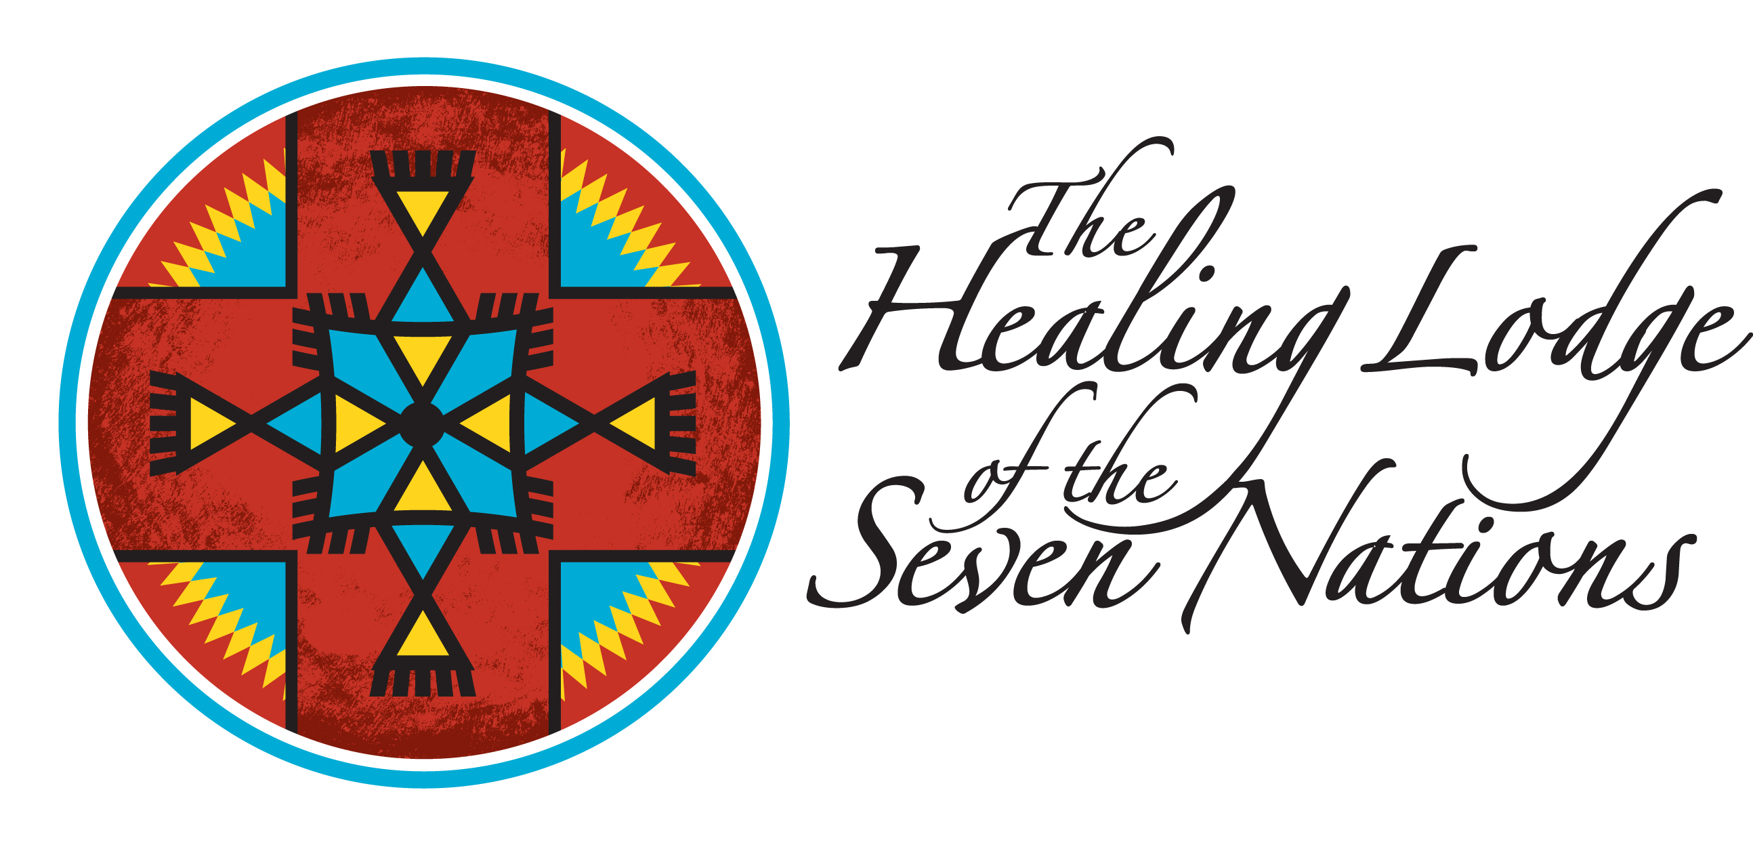

Prepared Statement of Dr. Martina Whelshula,
Administrative Director for the Healing Lodge of the Seven Nations

United States Senate
Committee on Indian Affairs

Oversight Hearing on the Increase of Gang Activity in Indian Country

November 19, 2009

Good afternoon Chairman Dorgan, Vice Chairman Barrasso, and members of the Committee. My name is Dr. Martina Whelshula and I am a member of the Arrow Lakes Nation of the Confederated Tribes of the Colville Indian Reservation, and Administrative Director at the Healing Lodge of the Seven Nations, a 30-bed adolescent inpatient chemical dependency treatment program located in Spokane Valley, Washington. Recognizing the need to protect future generations, seven tribes from three different states came together back in the 1980s to start this treatment facility, which receives Native American youth from the Western United States, including Alaska. While we are a Native American focused treatment program, we do accept youth from all cultural and ethnic backgrounds into our program.

I appreciate this opportunity to testify today on the prevalence of gang activity in Indian Country. Specifically, I will address the increasing incidence of gang involved youth coming to our program, and the barriers it creates for the program, its participants, and in returning the young people to their communities at the completion of treatment.

Accompanying me today are two young men who were involved in gangs and are currently in our program. They will remain anonymous as they are both under the age of 18, and would like to maintain their privacy regarding their alcohol and chemical dependency status. They are here to help answer your questions.

GANG INVOLVED YOUTH AT THE HEALING LODGE

While we do not have any empirical research on why our young people choose to join gangs, after speaking with several of our counselors, a definite pattern starts to emerge. For the most part, youth are looking for some place to belong. Many come from lower socio-economic situations, perhaps from struggling families, and the gang may be the only family that they have known. Many, many of our youth come from families where drug involvement is intergenerational – and the family unit is compromised. Also of concern is the number of parents who are incarcerated or deceased due to various reasons including alcohol and drugs as well as gang involvement.

By introducing or reintroducing our Native youth to their cultural heritage, we are able to give many a sense of belonging to more than just their gangs. The tribe or tribal community becomes the “family” that they long to belong to, and for many it becomes clear that the gangs are there to break down this foundation. Reservation life can be hard for them to navigate. With most of their friends, family and the community involved in alcohol, drugs and gangs, it is hard for them to see a way out. We help them to find their inner strength, to identify the positive people in the families and communities, and help them to establish a strong foundation to lean on when they leave treatment.

The Healing Lodge admits roughly 150 youth each year into treatment. Of the 150 youth, it would be safe to say that at least two thirds come gang involved. Some residents are more heavily involved than others, while others are second and third generation gang families. Our youth have stated that all gang members they know are drug involved or addicted.

Engaging in gang activity during treatment creates a huge barrier to the success of their treatment and recovery, as well as, that of their peers. As a program, we prohibit any signs of gang activity. We make it clear that treatment is neutral ground for all of our residents.

One resident who came to us heavily involved used treatment as an opportunity to reflect upon his life and his future goals. He stated that he was tired of being scared, worried, and paranoid. He feared for his life all of the time. In treatment he could let his guard down and find safety in the therapeutic environment. He became involved in the Sweat Lodge and other spiritual activities. When he left, he was very motivated to leave his gang. Upon his return home, his family uprooted him and moved him back to their home tribal community several states away. When we followed up with him, he was doing well. He was thankful that we helped him get his food handler’s permit, because he was able to find employment right away.

Another resident was reflecting during a counseling session and suddenly he blurted out, “I’m gonna move… I’m gonna move… I don’t want to die.” Since he was in a relationship with a young woman and they were expecting a baby, he thought that was his way out. It was an honorable way to leave the gang; to take care of his new family.

One resident almost died prior to attending the Healing Lodge. While at the Lodge he was reunited with his spiritual traditions. This reunification was powerful and he made a commitment to go home and rejoin his extended family. He wanted to prove to his uncle that he was serious about rejoining the ceremonial traditions of his family; so he learned a new song to take home to his uncle. Songs are very important in tribal cultures.

There are many success stories of residents who discover their true selves in the context of a beautiful culture that does not judge them and only welcomes them back into the circle of community. Our young men and women find a new sense of belonging in traditions hundreds of years old. Our cultural specialists are gentle, loving adults who provide the cultural and spiritual guidance our young people miss so much.

Although our mission is to treat our youth for alcohol and substance abuse, our approach treats the whole child within the context of a rich culture.

WHAT MORE CAN BE DONE?

There is a need for help to build stronger families, communities, and cultures. Many Native communities have taken on this task, but with limited resources and a lack of experience, they have not had great success.

Our recommendation would be to authorize new programs or augment existing programs that provide grants to schools, tribes or tribal organizations like the Healing Lodge that have demonstrated gang problems to implement culturally appropriate education, intervention and prevention activities.

- As stated by Brendtro, Broken Leg, Van Bockern in their book Reclaiming Youth at Risk:

It is of the highest imperative that the modern family be strengthened and stabilized. Today, the typical child is reared by a single parent or by parents who both work outside the home. The decline of extended families and intimate neighborhoods leaves an isolated nuclear family. Public policy has not kept pace with the reality that one or two unsupported adults are often unequipped to successfully rear their young. Many young people roam the streets in pursuit of meaningful human bonds. The tragedy is that, for many, their only option is to seek out relationships with other outcast and unclaimed youth.

This concludes my statement. At this time, I would be happy to answer any questions the Committee may have. For the safety of the two young men with me, I respectfully request that questions directed to them not involve answers that may compromise their identity. Thank you.

