UNITED STATES SENATE COMMITTEE ON INDIAN AFFAIRS
HEARING ON
“STOLEN IDENTITIES: THE IMPACT OF RACIST STEREOTYPES ON INDIGENOUS PEOPLE”
TESTIMONY OF
JIM E. WARNE, PRESIDENT
WARRIOR SOCIETY DEVELOPMENT
&
EDUCATOR
SAN DIEGO STATE UNIVERSITY
MAY 5, 2011

INTRODUCTION
Good morning Chairman Akaka and distinguished committee members;
It is an honor to be invited to provide testimony before the Senate Committee on Indian Affairs. I am Jim E Warne, member of the Oglala Lakota Nation of the Pine Ridge Reservation, South Dakota. I am president of Warrior Society Development, former professional National Football League Player, Actor, Educator at San Diego State University, and Ph.D. Candidate of University of Northern Colorado. I am also a life-long supporter of organized sports from youth sports leagues, collegiate athletics, and professional organizations. During the summers, through my company, Warrior Society Development, LLC, I provide a sports education to children of different Tribal Nations providing athletic activities integrated with cultural and traditional values.
I am a proud Oglala Lakota Tribal member and I am a proud American citizen with some Euro-American ancestry. I am a member of the Consortia of Administrators for Native American Rehabilitation. I am the Director of the Center of American Indian Rehabilitation and Education (CAIRE) at San Diego State University Interwork Institute. I coordinate the Post Employment Training American Indian Rehabilitation Post-graduate certificate program under CAIRE.
Thank you for the invitation to present at this important hearing regarding “Stolen Identities: The impact of Racist Stereotypes on Indigenous People”. I want to share my perspectives and experiences as a retired professional football player, actor, educator and advocate for Indian issues and disability awareness.
Testimony for US Senate Committee on Indian Affairs Oversight Hearing on "the impact of Racist Stereotypes on Indigenous People" is only one of the many pressing and challenging issues facing American Indians and Alaska Natives. My wife, Jill Sherman-Warne is a member of the Hoopa tribe and former elected leader of the Hoopa tribe often expressed frustration about the Mascot issue, seeing it as a distraction from the pressing issues of everyday reservation life where the struggle to meet basic needs like sanitary housing, potable water, access to health care and adequate food are deemed basic priorities to be considered before intellectual discussion of mascots.
While I believe it is important to address the racist stereotypes, I do acknowledge that there are so many important and pressing issues facing Indian country including: attacks on Tribal Sovereignty, cuts to the already meager funding of Indian Health Services, Indian Education (opportunities for Indian to receive an education), growing environmental justices issues, increasing rates of disability, mortality and suicide followed by the continuation of higher unemployment rates than another minority group. The Economic Policy Institute in its December 2009 issue brief acknowledge that Indian experienced double digit unemployment rates for most or all of 2009. Indian people and Tribal Nations continue be the lowest socio-economic population in the US. Some will quickly refute this idea by pointing to the success of Indian gaming; however, those tribes experiencing significant financial success number less than 25 tribes impacting less than 50,000 tribal people nationwide.
My people, the Oglala Lakota Nation on the Pine Ridge reservation located in Shannon County, is one of the most economically depressed counties in the nation, and five of the top ten poorest counties in the country correspond to reservations in South Dakota.
Each of these issues deserves its own hearing to ensure that the issues are adequately addressed followed by major budgetary and funding considerations. I urge the committee reflect on the need to address these other pressing issues that challenge Indian Country.
From my perspective, there are multiple obstacles to eliminating the racist stereotypes in the US as it relates to Indian people. These include inaccurate and incomplete history classes in American schools, a long history of accepted use of inappropriate Indian imagery in the American mainstream media, lower socio economic status of American Indians and subsequent lack of political power and representation, and a general lack of respect for Tribal Sovereignty. Today I will focus on educational and media issues.
EDUCATION—Improve history classes in American Schools
The American educational curriculum typically does not adequately address Indian history, if it did, we would not be here today addressing this issue. History is taught from the White perspective. For example, we often hear that Columbus “discovered America” indicating that the millions of indigenous people already here are somehow less than human. In recognizing and honoring Columbus, do we bother to even acknowledge the thousands of people he enslaved, tortured and killed? Do we learn about the significant contributions made by American Indians to this nation? For example, how many people are aware that the U.S. Constitution is based on the organization of the Iroquois Confederacy?
I raised my son, Ryan, to respect the traditional values of the Lakota way. Ryan’s educational experiences have not always been positive. On occasion he has had to challenge his peers and his teachers regarding inappropriate views and instruction on Indians. A few times, his teachers have punished Ryan because he would provide the Indian perspective to the American historical perspective being taught.
In our schools, Indians are more often thought of as “Braves” or “Redskins” or “Savages”, and non-Indians dress up in their version of a stereotyped Indian to support school sports. In this setting, wearing feathers, war paint and doing the “tomahawk chop” is offensive and reinforces racism and stereotyping of our people. If the Atlanta Braves were the Atlanta Slaves, and the White fans wore shoe polish on their faces and did the “Spear Chuck” it would be seen as terribly offensive. However, this society allows for mockery of our culture and continued degradation of our people and traditions. This occurs in professional sports and in our public schools.
If the educational curriculum was truthful and sufficient to educate the next generations of citizens, they themselves would have realized that these images are racist and do not belong in our American culture.
Today’s average U.S. education about Indians is reduced to cutting out construction paper feathers, coloring book tepees and tomahawks, and Pilgrim hats for Thanksgiving. We celebrate Thanksgiving and teach our kids that Indians and Euro-American settlers lived in harmony and shared dinners together--this is considered Indian history in our school systems!
Most Americans do not even know about the recognized holiday the Friday after thanksgiving. I appreciate that Congress finally decided to recognize Native American Heritage Day, yet the US population is unaware of this holiday as it was placed the day after Thanksgiving so that an additional federal holiday was not to be enacted. Most Americans are not are aware of this holiday that honors Indian people, yet they are probably aware of Martin Luther King day, Cesar Chavez Day in California and other holidays that honor certain populations.
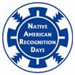
If the American educational curriculum provided accurate information on Tribal sovereignty, the conflicts and massacres, the breach of contract (treaties) and a comparative analysis of Colonialism – Holocaust – Genocide, we probably would not have to be here discussing racist American Indian stereotypes. If there was a stronger focus on Indian and Tribal perspectives and not just that of the conquerors, awareness would improve and the racist use of Indian imagery would not be tolerated.
The use of Indian imagery in mascots promotes socially accepted racism and stereotypes. For example:
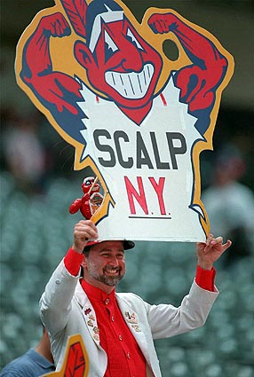
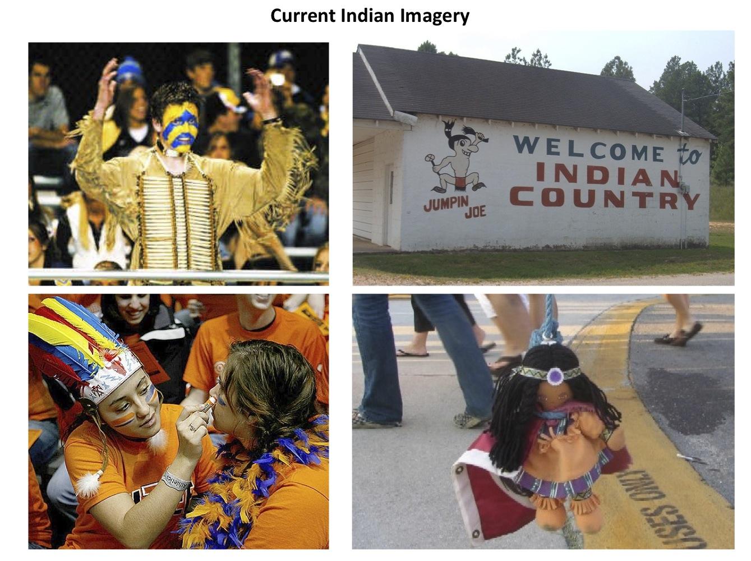
Use of Mascots and Themes by American System
Many schools and universities are using Indian Mascots. For some, a school mascot may be the only education they receive about Indian culture and history. San Diego State University had the Monty Montezuma mascot, and the issue was addressed. 95% of the students and faculty that participated in the survey indicated that they still wanted the mascot that offends. SDSU is exempt from NCCA sanctions (i.e. Sweet Sixteen for the men’s basketball this year), as the Aztec Tribe has no federal or state recognition in the U.S.
My son Ryan and I were at an SDSU Aztecs football game and the mascot walked by and Ryan, who was 7 at the time, said, “Hey dad, there is an Aztec!” I indicated that it was a “White guy doing a very bad imitation of an Aztec!”
Shortly after this incident, I was proud that SDSU President, Dr. Stephen Weber, made the decision to no longer sanction the Monty Montezuma mascot as a result of the 5% of students and faculty that indicated it was inappropriate imagery of the Aztec culture. SDSU faced a lot of resistance to the change, but SDSU administration made this decision and supported the NCAA policy regarding the ban on the use of negative cultural imagery.
MEDIA—Recognizing the Continued Use of Stereotypes
I have been fortunate to pursue my dreams of professional football, acting and higher education. My experience in Hollywood film and television has been interesting. I have a particular look and physical size that impacts the roles that I can play. Do you think I get to audition for a character of a doctor, lawyer, educator or “good guy?” No. My roles have included Bull (a Seminole contracted killer), henchmen, bodyguard and one role was literally “big Indian” with no other reference.
Hollywood and Television
There are many examples of film and TV show that have portrayed Indian people in a stereotypical way. I was auditioning for a role and the star and producer can up to me at Sony Studios during the full cast script read and he said that he “wanted me to sound more foreign”. I indicated that he wanted the “stereotype Hollywood Indian”. I did not get the part. The script was changed to portray the stereotype Indian that he preferred.
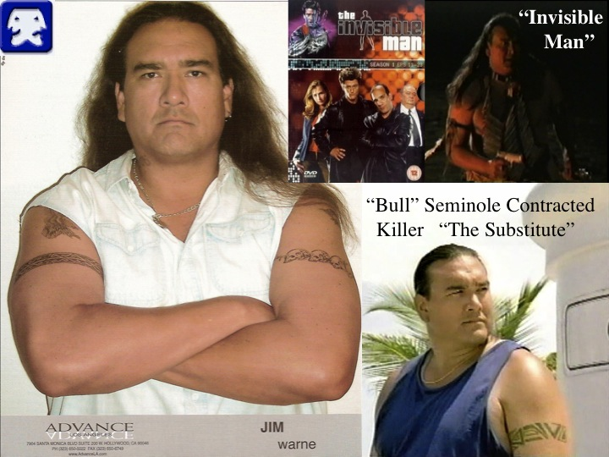

Media and Advertising
The need for respecting other cultures has been recognized, and inappropriate imagery has been removed from many organizations, institutions and advertising (i.e. Pickaninny, black face, yellow face, Sambo, Lazy Peon, Pillsbury Funny Face drink mix and more recently the Wong Brothers advertising campaign by Abercrombie and Fitch) referenced below.

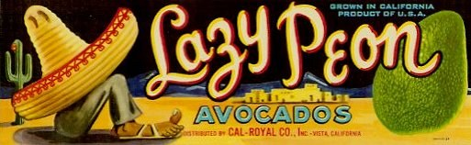

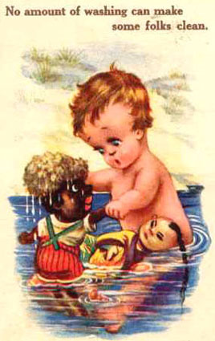
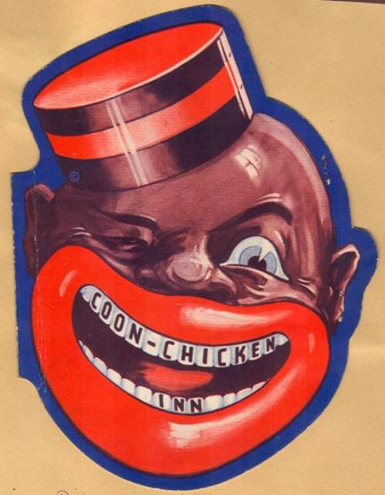
Sambo reference was not only the Pancake House.
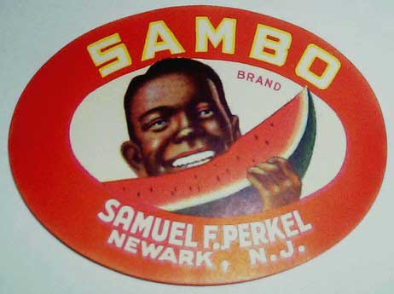
One of the early changes of the Indian image used by Pillsbury Funny Face Drink Mix.
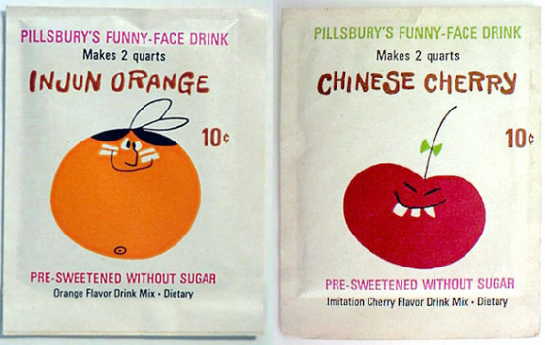
Asian groups stopped a recent offensive ad campaign due to protest.
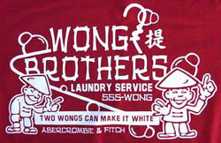
America’s awareness and consciousness of other cultures inappropriate imagery is proven, yet, American Indian inappropriate imagery continues, why?
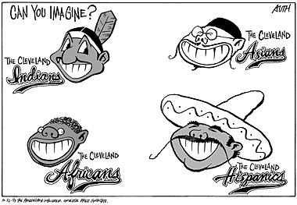
Unfortunately, we can imagine these images, and indeed have to experience these types of images, as it is present today for Indian Country.

As American Indians, we are simply asking for the same respect that has been shown to other cultures whose imagery was inappropriately used.

Conclusion

They willingly traded everything they owned…. They were well built, with good bodies and handsome features…. They do not bear arms, and do not know them…. They would make fine servants…. With fifty men we could subjugate them all and make them do whatever we want (Columbus’ log on first contact in the “Indies” 1492) (Zinn 1995).

Chairman Akaka and members of this Subcommittee, thank you again for the opportunity to highlight for you some of the mascot and media imagery issues we face in Indian Country. I hope you will agree with me that this form of racism has no place in modern American society.

When appropriate, I am happy to answer any questions you may have.

