Written Statement of

JERILYN DECOTEAU

FIRST NATIONS DEVELOPMENT INSTITUTE

PREDATORY LENDING AND ITS IMPACT ON NATIVE AMERICAN COMMUNITIES

Senate Committee on Indian Affairs
Dirksen Office Building
June 5, 2008

Chairman Dorgan, thank you for inviting First Nations Development Institute to testify here today on a matter of great importance for Indian Country and for the nation as a whole -- that of lenders who prey on vulnerable borrowers, resulting in loss of individual assets and economic security. For Indians, predatory lending results in the bleeding away of crucial assets from Native American communities. These communities already lack the basic economic structures that other communities take for granted and are struggling to meet the federal and tribal goal of economic stability and self-sufficiency.

First Nations Development Institute (FNDI) is a 27-year-old nonprofit headquartered in Longmont, Colorado with offices in Fredericksburg, Virginia, whose work is with tribes and Native communities across Indian Country.

FNDI’s mission is to restore Native American control and culturally-compatible stewardship of the assets they own - be they land, human potential, cultural heritage, or natural resources - and to establish new assets to ensure the long-term vitality of Native communities. FNDI does its work using a three-pronged strategy of educating grassroots practitioners, advocating systematic change, and capitalizing Indian communities.
FNDI’s core belief is that “when armed with appropriate resources, Native Americans have the capacity and ingenuity to ensure the sustainable economic, spiritual, and cultural well being of their communities.”
Directly relevant to the topic of this hearing is FNDI’s recent report, Borrowing Trouble: Predatory Lending in Native American Communities. The report is the outcome of a research study conducted by FNDI under a grant from the Annie E. Casey Foundation. Our report provides an analysis of survey data collected from attendees at the National American Indian Housing Council meeting in May 2007; survey data collected from Native users of selected Voluntary Income Tax Assistance sites; geo-coded data of payday lenders, bank branches, and Native community development finance institutions; and a national data set of home mortgage loans. The report also presents five case studies of promising practices and concludes by offering concrete suggestions about the steps Native nations can take to curb the impact of predatory lending on their citizens.

The purpose of the study was to produce original research on the extent of the problem of predatory lending in Native American communities and to document local solutions currently being practiced by tribal housing authorities and tribal governments. A predatory loan is commonly understood to be an unsuitable loan designed to exploit vulnerable and unsophisticated borrowers. Predatory loans may have inappropriately high interest rates or fees or terms and conditions that trap borrowers; often, these conditions are not well explained to borrowers. When borrowers fall prey to these practices, they often cannot afford to repay the loans, and end up in foreclosure, bankruptcy, or other financial hardships. We wanted to understand the effects of predatory lending on Native communities and collect data on payday loans, pawnshop transactions stores, car title loans, Refund Anticipation Loans, and mortgage loans with high interest rates and hidden fees.

Predatory lending is a nationwide problem, but for Indian tribes the bleeding of assets away from Native communities has consequences of a greater dimension. The very survival of tribes is linked to securing comprehensive strategies for economic improvement. Many Indian people are poor, and when even paychecks are taken from them, the dream of homeownership and building stronger communities is beyond hope.

We are pleased to share with you some of what we have learned about lending industry practices and the special problems they presents to members of Native communities. We are also pleased to share our policy recommendations, based largely on best practices in the case studies conducted on five Native programs. These best practices provide alternatives to predatory loans, help build individual assets, and in turn help tribal communities develop stronger, more secure economies.

Our written statement expands on our oral testimony addressing the issues of concern to the Committee:

- Identifying the problem: We will discuss the findings of our study and provide examples of predatory lending through personal stories told to us.
- Addressing the problem: We will describe tribal practices and programs that are having good results in combating the effects of predatory lending.
- Policy recommendations: We will recommend policies and programs that will promote asset building and curb predatory lending practices that affect Native American communities.

- Identifying the Problem: Predatory Lenders Make it Difficult for Individuals to Build Assets, to Become Mortgage Ready, and to Move Out of the Cycle of Debt.

History is replete with examples of predatory practices involving Indian assets, from theft of land to gross underpayment for the lease or sale of natural resources. Now predators are reaching directly into Indians’ pockets for their paychecks and tax refunds. This is in large part because vulnerable Indians have no other assets to steal.

Payday Lenders

Many Indians who use payday lenders lack access to mainstream banking services, either because there are no such institutions nearby, or because borrowers lack collateral (for example, no home equity), have poor credit, or no credit history. To get over a financial crisis, such as a car repair, medical bills, a missed mortgage payment, or a heating bill in winter, many people have no alternative but to turn to lenders who can dictate the terms. This fairly describes the situation for too many in Indian communities, where wages are typically low. For example, the median household income for American Indians and Alaskan Natives is $33,132; the poverty rate is 23 percent. By comparison, the median income for whites is $46,971 and the overall poverty rate is 12.7 percent. Recent research by the Harvard Project on American Indian Economic Development suggests that this contrast is even more stark for reservation residents - in 2000, the per capita income for residents of Indian reservations was $7,942 as compared to $21,587 for the total United States.

The number of payday lenders has exploded in the last 20 years. In the early 1990s there were around 300 payday lending outlets in the United States; recently the count was higher than 22,000. For comparison purposes, there are 13,300 McDonald’s restaurants and 7,087 company-operated Starbucks according to those chains' web sites. In New Mexico, a state that has relatively lax regulation of payday lenders, there are 4 payday lenders for every McDonald’s.

The increase has been due to a number of factors, including deregulation of the lending industry in the 1980s and 1990s. Protective measures such as “truth in lending” have not been effective in curbing abusive lending practices. Data from the industry itself suggests that the average payday loan borrower is low-income and minority: a borrower is more likely to be Latino or African American, a renter, and have a median income lower than the U.S. average.

The Center for Responsible Lending reported in 2006 that most payday loans cost $15-$30 per $100 for a two week term, resulting in effective annual rates of 390 to 780 percent interest. The typical payday borrower rolls his loan over several times and eventually pays back $793 for an initial $325 loan. Ninety percent of the revenue generated in the payday-lending industry comes from borrowers who are trapped in a cycle of payday loan debt, or those who take five or more loans a year. Fees play a key role – the Center for Responsible lending estimated that the industry brings in $4.6 billion in fees per year. The total impact on the poor and effect on the economy has been quantified at more than $8 billion a year.
In their editorial “Beyond Payday Loans” in the Wall Street Journal (Jan. 24, 2008), President Clinton and California Governor Arnold Schwarzenegger said, “Imagine the economic and social benefits of putting more than $8 billion in the hands of low-and middle-income Americans. That is the amount millions of people now spend each year at check-chasing outlets, payday lenders and pawnshops on basic financial services that most Americans receive for free – or very little cost – at their local bank or credit union.” According to the Report of the Native American Lending Study, most Native communities do not have access to local banks and very few have access to credit unions. This makes them easy prey.
According to 101 survey respondents at the April 2008 National Indian Gaming Association Trade Show and Convention, predatory lending is a significant concern across Indian Country: 73 percent indicated that they “Strongly Agree” or “Agree” with the statement that predatory lending is a problem in their community (38% of respondents were elected tribal officials). This corroborates the results from 140 respondents to a survey at the annual National American Indian Housing Council (NAIHC) meeting held in May 2007. Seventy-three percent of the respondents to that survey also reported that predatory lending was either “a big problem” or “somewhat of a problem” in their communities.

Respondents to the NAIHC survey represented over 67 tribes in 28 states. Their insights are valuable because tribal housing professionals are uniquely placed to observe and understand the impact of predatory lending practices in their communities. They assess clients’ eligibility for housing assistance, provide advice about mortgage access, and often offer financial education and credit repair services; their perceptions of predation are based on these interactions.

When asked about specific predatory practices, 67 percent of respondents to the NAIHC survey identified payday loans as either “somewhat of a problem” or “a big problem.” Thirty-three percent of respondents stated these loans are a problem because a lot of people have them, and 63 percent stated that the interest rates on these loans are too high. Sixty-two percent responded that they feel that payday loans prey on vulnerable people. Significantly—and perhaps to be expected—the most common reasons respondents cited for clients falling prey to predatory lenders and products included a generic need to get access to cash and the more specific need for money to pay bills.

Drawing upon geo-coded data of payday lenders (provided by Dr. Stephen Graves at the California State University-Northridge who has identified a pattern of predatory lending in relation to military bases) we produced several maps of the location of payday lenders in relation to several Indian reservations (see maps of South Dakota and Gallup, New Mexico at the end of this testimony). The maps drive home the point that American Indians living on or near tribal lands have nearly as many payday lending choices (red dots) as bank branch choices (green dots). Our map of the Gallup, New Mexico area demonstrates that citizens in that community, 75 percent of whom are Native American, have nearly twice as many payday lenders than banks to do business with.

South Dakota provides an interesting example. On November 26, 2007, The Rapid City Journal observed, “Rapid City, with its proximity to Ellsworth AFB [Air Force Base] and its growing Native American population, is particularly vulnerable to the payday industry. Pennington County has just 12 percent of the state’s population, but it contains almost one quarter of its payday lending operations.” As many as one in five members of the armed forces took out a payday loan in 2005, a Pentagon report said last year, contributing to rising debt levels that interfere with troop deployment and service members' security clearances. South Dakota eliminated usury laws in 1980 as a means of attracting financial services businesses. As compared to other states, it now has the highest number of banks per capita and the second highest number of payday lenders.

Given the strong service orientation of payday lenders and their allied businesses as compared to that of banks, and given many reservation residents’ limited experience with banks, ready access to payday lenders has translated to predation and escalating debt for numerous Native consumers. One participant in a breakout session on asset building at the National Congress of American Indians 2007 midyear conference in Anchorage, Alaska put this access and experience linkage succinctly: “When people like me go and look for a loan, our only friends are the predatory lenders.”

Refund Anticipation Loans (RALs)

Loans against tax refunds are another common form of lending that is receiving increasing scrutiny. These loans are appropriately termed refund anticipation loans, or RALs, but they are perhaps best (but inaccurately) known as “rapid refunds.” Those taking out RALs pay large fees to receive an immediate payment by taking a loan against their tax refund – in many cases receiving their money only a few weeks earlier than they would have otherwise. This can result in an effective annualized interest rate of anywhere from 70-700 percent, depending on the size of the tax refund. Research has shown that RALs are heavily marketed among low-income populations, especially those that qualify for the Earned Income Tax Credit (EITC). Our research suggests that many people in Native communities are not aware that they could have their taxes prepared free of charge, or that they could access the EITC without paying for tax preparation.

Sixty-eight percent of respondents to the survey administered at the National American Indian Housing Council (NAIHC) meeting identified loans against tax refunds as “somewhat of a problem” or “a big problem.” Forty-three percent of respondents stated that these loans are a problem because a lot of people have them, and 53 percent believe that the interest rate is too high. Fifty-five percent of respondents stated that they believe these loans are a problem because they prey on vulnerable people.

Data is available at the county level regarding the usage of Refund Anticipation Loans. An analysis of the top ten states with the largest American Indian/Alaska Native population indicates that among the counties with 50% or more American Indian/Alaska Native population (usually indicating a reservation), usage of Refund Anticipation Loans was nearly 4 four times more likely than among non-Native majority counties. Over 28,000 people in these Native-majority counties used a RAL in 2005, amounting to a total cost of approximately $6,888,000 paid for the RAL service.

In early 2007, the Gannett News Service analyzed data from the IRS (originally obtained by the National Consumer Law Center) and ranked the counties in which the take up of these loans was the greatest. The top four counties on the list are “Native counties” in South Dakota and North Dakota—counties where land is largely reservation land and at least 80% of the population identifies as Native.

In Shannon County, SD, part of the Pine Ridge Reservation, 62% of taxpayers eligible for federal tax refunds received a refund anticipation loan for the 2004 tax year. In Todd County, SD (where the Rosebud Reservation is located), Buffalo County, SD (where the Crow Creek Indian Reservation is located), and Sioux County, ND (where the Standing Rock Reservation is located), the percentages were 56%, 51%, and 49% respectively.

The cost of this activity is substantial. Looking at the 2005 tax year (taxes filed in 2006), the National Consumer Law Center estimated the annualized interest rate for a loan covering the average refund (about $2,150) at 178%—or a $100 cost in addition to the fee for tax preparation (which averaged $146).

The Kathryn M. Buder Center for American Indian Studies and the Center for Social Development at Washington University in St. Louis calculated comparable costs for the 2005 tax year among Native clients of Volunteer Income Tax Assistance (VITA) sites. Some 600 of the 2,300 Native clients who were surveyed during the 2007 tax season reported using a paid tax preparer in the previous tax year. Over half of those filers accepted a RAL. On average, those accepting a RAL paid $189 for tax preparation services, as compared to $121 for those who did not.

Volunteer Income Tax Assistance (VITA) sites in Native communities have been effective in reducing the use of paid tax preparers who often charge fees and offer clients Refund Anticipation Loans. The Menominee housing authority initiated a VITA site for the Menominee reservation when they found out that Menominee County, whose boundaries are the same as the reservation, had the highest usage of Refund Anticipation Loans in the state in 2002 (the top four cities were also on Wisconsin Indian reservations). The VITA site on the Menominee reservation processed over $560,000 of federal refunds in 2007, an increase of 23% from the previous year. A total of 439 returns were processed free of charge, potentially saving over $120,725 in preparer fees for the community that year.

Evidence of Other Predatory Lending Practices

In our research report Borrowing Trouble: Predatory Lending in Native American Communities we identified several other predatory lending practices that are affecting Native communities. Fifty percent of respondents to the survey administered at the National American Indian Housing Council (NAIHC) meeting identified car title loans as “somewhat of a problem” or “a big problem.” Fifty-four percent identified mortgage loans as a “somewhat of a problem” or “a big problem,” and fifty-eight percent identified pawn shop transactions as “somewhat of a problem” or “a big problem.”

Due to the presence of trust land on Indian reservations and the difficulty in getting private mortgages, abusive mortgage lending may be less of a problem on Indian reservations than in urban areas. However, data in our research report demonstrates that nationwide, between 2002 and 2005, American Indians borrowed from lenders engaged in the subprime mortgage market at a rate disproportionate to that of non-Indians. Comparing the percentages of loans made by high-cost lenders to American Indians and Whites, we found that Natives were engaged with the high-cost market more than twice as often as Whites (disparity ratios in the range 2.06:1 to 2.32:1). This suggests that nationwide, Native borrowers remain more at risk of the negative outcomes associated with subprime lending than non-Natives.

The Cost of Predatory Lending in Native Communities

The report Borrowing Trouble: Predatory Lending in Native American Communities provides case study data on the impact of abusive lending practices on Native communities (and therefore Native economies). Our case study research included interviews with several key informants who work in economic development organizations and coordinate asset-building programs. In all five of our case study sites, economic development practitioners identified predatory lending as a problem that strips economic resources from economically stressed families. One practitioner put it this way:

First and foremost it affects the financial security of the family. Many of our families are just one minor emergency away from extreme financial hardship. This in turn affects family relations—stress, divorce, bankruptcy, child welfare. The extreme cost of predatory lending dramatically decreases living standards (eventually, if not immediately). The aggressive nature of predatory lenders encourages poor financial management practices, which make this a perpetuating cycle. Many of our clients come to us in extreme emergencies regarding foreclosure, utility cutoff, or repossession because nine out of ten times they have been making their predatory loan payments and foregoing essential payments—the predatory lenders are such aggressive collectors (and many times not ethical or legal) that families forgo making shelter, utility, and transportation payments just to satisfy the predatory lender. High fees lower the standard of living and drain money from the general economy, particularly with non-local predatory lenders. The financial stress involved for families borrowing from predatory lenders also negatively affects workplace productivity, which drains resources from the local economy.

Many of the economic development practitioners we interviewed work on repairing their clients’ credit so that they may qualify for asset-building programs such as those focusing on small business development or homeownership. Nearly every practitioner we interviewed identified the need to repair credit or extract people from predatory loans as one of their highest priorities.

Several examples of the devastating outcome of predatory lending emerged from the study and our follow-up research:

- A middle aged man took out a payday loan to pay his electric bill. The high interest rate and hidden fees, the cost of which became a cyclical drain on his paychecks, eventually took his whole regular paycheck plus $200 to pay.
- A tribal member purchased a home with a loan from his housing authority but then took another loan from a predatory lender, with a high interest rate. The family fell behind on payments and lost their home.
- A tribal member who owned his home outright after 30 years of payments got a home improvement loan from an unscrupulous lender and eventually lost his home.
- A community practitioner on a reservation in Arizona stated that she has seen a lot of problems with trailer loans. She provided an example of one case in which an individual was given a loan on a trailer but it was not explained that a trailer is a depreciating asset. The loan had a 29% APR even though the borrower had good credit and a decent income. The trailer owner wanted to sell the trailer and buy a home, but was so far in debt (also called being “upside down on a loan”) that she was not able to sell the trailer. The trailer owner owed $60,000 on a trailer that was worth about $15,000.
- A woman earning minimum wage borrowed $400 and ended up owing $1,400. The lender took her to court. She ended up owing $2,200 including court fees. The lender would not work with her on a repayment plan that she could afford.
- A 21 year old on a North Dakota reservation wrote two letters and went in person four or five times to a payday lender to try to work something out. When he was $600 in debt, the lender threatened to take him to court. His mother bailed him out. She said payday loans are common and she believes youth are targeted. She said she is not surprised that individual stories are hard to get because people are ashamed and will not talk about the trouble they are in.
- A couple on a North Dakota Reservation used RALs every year from 2000-2007. They paid $150 plus tax preparation fees of $70 on refunds of $1,800-$2,400. The tax preparer comes to the reservation 2 days a week during tax season. He offers people a RAL every time. The couple said RALs “are the norm, especially if you get a return of around $4,000-5,000. You don’t see it [the interest] and you don’t feel it. People get RALs as soon as they get their W-2s. You can even take your last pay stub of the year and get a loan. After Christmas, people need the money - sometimes they skip a bill in December and they have a double payment in January.”
- This same woman, when asked about payday loans, said yes people use them, but first you have to have a job and the unemployment rate here is 73% according to B.I.A. statistics. The woman is the employment outreach coordinator at the tribal college.
- On the same North Dakota reservation, two women obtained car loans for 14% and 18%, respectively. Both have longtime professional jobs. One fell behind in student loan payments, but is nearly caught up. She does not keep a checking account or use a credit card, so besides the student loan, has no credit. The other fell behind on credit card payments and is paying off current debt, but no longer uses credit cards.
- A lawyer employed by the United States Department of Justice, with a credit rating of 780, wanted to help his son buy a car. Two banks just off a North Dakota reservation offered him13%-18% rates. One bank explained that rates were higher for reservation borrowers because the lender might be subject to tribal laws and tribal court jurisdiction. The lawyer went home to Michigan and obtained a loan for 6 ½%. He reported the problem to the Civil Rights Division. He noted that a simple investigation using undercover borrowers would quickly document this type of discrimination.
While these stories are anecdotal, we believe that they illustrate the problems created by predatory lending in Native communities. Loans that charge high interest rates or fees are often made to people who do not understand the terms of the loans, are not qualified to receive them, and are not able to pay them back. The most notable outcome of these predatory loans is asset stripping, or the draining of economic resources away from Native families and communities. Given that many Native families and communities are already experiencing economic hardship, the outcome of predatory lending is especially problematic for them.

- Addressing the Problem: Providing Financial Education, Alternatives to Predatory Lending Products, and Consumer Protections

The report Borrowing Trouble: Predatory Lending in Native American Communities presents case studies of five tribal programs whose innovations with financial education, alternative financial services and products, and other asset-building programs and strategies are helping to eliminate reliance on predatory lending, repair credit and build economic security.

In these five communities, economic development practitioners are developing innovative strategies to combat predatory lending. These strategies include providing financial counseling, credit repair, and financial education to encourage people to avoid using predatory lenders, and using community development financial institutions (CDFIs) to provide alternative credit products to borrowers. Additional research in the report demonstrates that tribes can also set interest rate caps that may reduce the incidence of predatory lending on reservations.

Our recommendations, based on the findings in our study, are that tribes and tribal organizations should:

- Develop credit programs and borrowing opportunities that reduce the demand for predatory loans.
- Develop consumer education programs that assist in financial planning, savings and credit repair.
- Set interest rate caps.

Deserving special emphasis are Community Development Financial Institutions.
Native CDFIs meet a market demand met by few others in the local community. They can provide affordable access to credit for borrowers with poor or no credit while at the same time providing financial education and helping the borrowers build assets. David Fleming, former director of the Lac Courte Oreilles Federal Credit Union (LCOFCU) provides an example of this approach:

Our goal is not to make a lot of money, but to establish a healthy relationship with that borrower. Instead of going to pawn shop or payday lender, they come to us. We want to build relationships with borrowers. The goal of the credit union is to provide an alternative, getting people to come in the door. We hope they are learning to trust banks. Many have never been in a bank before.

Staff at LCOFCU work closely with borrowers when necessary. David Fleming stated,

When someone lost their job at the tribe, or couldn’t pay their loan, we wanted them to be comfortable coming to talk with us. We would work with them to refinance, or lower the payments on the loan until they got back on their feet. This made a difference and helped people learn to trust us.

Another lesson learned is that the “low stakes” loans are important stepping stones to becoming credit worthy. Smaller consumer loans, including one called the “Easy Money” loan, allows people to learn to use credit responsibly. Payroll deduction was used to ensure that people had a low default rate. David Fleming stated,

Many people told us that the “Easy Money” loan made them credit worthy – gave them a credit history, or helped improve their credit score. We reported payment on those loans to the credit agency and it helped people establish or repair credit. People told us that it made them eligible for a home loan later on.

FNDI supports the 2008 policy recommendations made by the Native Financial Education Coalition, which were based in part on FNDI’s research. We agree that there is a need to expand financial education opportunities, combat predatory lending, improve institutional infrastructure, increase access to EITC, and promote and expand IDA utilization.

- Policy Recommendations

Our report Borrowing Trouble: Predatory Lending in Native American Communities focuses on what tribes can do to combat predatory lending, but there is also an important role for the federal government, as trustee with responsibility for implementing and overseeing the federal policy of tribal self-determination and protection of tribe sovereignty. Our first three recommendations focus on actions tribal governments may take, and our final recommendation provides suggestions for a federal role.

1. Recommendation One: Tribes Should Develop Credit Programs and Borrowing Opportunities That Reduce the Demand for Predatory Lending and Stem The Bleeding of Assets from Indian Communities

Tribes have the ability to develop their own financial institutions, and these financial institutions can offer alternative credit products to the citizens of Native nations. There are currently over 84 Native-owned banks, credit unions, and loan funds that are actively providing financial products and services to Native people, many of which have received support from the CDFI Fund as part of their Native American programming. As detailed in our report Borrowing Trouble: Predatory Lending in Native American Communities, several of these financial institutions currently offer short term consumer loans, which reduce the demand for high fee payday loans. Many of these financial institutions also provide financial education and credit repair in a variety of forms.

2. Recommendation Two: Native Nations Should Develop Consumer Education Programs that Assist in Financial Planning and Credit Repair

Consumers resort to payday, car title, pawn shop, and usurious consumer finance loans not only because they lack alternatives but because they lack experience in borrowing and investing. This is especially true in Native communities that are underserved by mainstream banking institutions. By providing financial education—from basic education on spending and saving to more complex education on credit repair and investment—Native nations arm their citizens against the practices of predatory lenders. Financial education can help tribal citizens avoid predatory loans in the first place and help those already in usurious situations extract themselves.

While our research shows that some financial education is already being provided in many Native communities through housing authorities, Native CDFIs, schools, and tribal colleges, research in other settings (among military service members) indicates that those most in need may be least likely to seek financial education—at least until there is no other alternative. These facts suggest that to be effective against predatory lending, financial education and remediation activities should be coupled with credit repair and preventive loan products, such as those described in the five case studies in our report.
The bottom line is that financial education is critical, but unlikely to be effective by itself, if there are no alternative lending services available.
3. Recommendation Three: Tribes Should Set Interest Rate Caps

Tribes should set caps on the interest rates offered by lenders under their jurisdiction, as a few tribes have done already, notably the Navajo Nation (21%APR); the Blackfeet Tribe (21% APR); and the Grand Traverse Band of Chippewa and Ottawa Indians (Homeownership Protection From Predatory Lending Ordinance).

This recommendation echoes the best policy advice from outside Indian Country. States such as New York and North Carolina have set effective interest rate caps and have made significant inroads against payday lending. Similarly, in late 2007, the U.S. Department of Defense issued regulations to implement the consumer protection provisions of Public Law 109-364 (The John Warner National Defense Authorization Act). These regulations set a 36% APR cap for loans to military borrowers. On January 7, 2008, the Department of the Treasury proposed a rule to limit the ability of tax return preparers to market RALs.

4. Recommendation Four: Effective Federal Policy Actions
The federal government, as trustee with responsibility for implementing and overseeing the federal policy of tribal self-determination and protection of tribe sovereignty, can act to limit predatory lending in Native communities. We recommend that the federal government: (a) assist in determining the economic and social impact of predatory lending practices on Indians and Native communities, (b) provide funding in support of increased financial education and alternative loan products; (c) develop a strategy to address the impacts of predatory lending and the flow of assets off of Indian reservations.
(a) Collect Data on Predatory Lending in Native Communities

The federal government should commission a detailed study of lending practices in Native communities, including all usurious and discriminatory practices, such as charging higher interest rates than are charged to off-reservation borrowers and refusal to make loans to people and businesses on reservations.
It is worth noting that discrimination in lending gave impetus to the founding of Turtle Mountain State Bank, which opened in December, 2007 on the Turtle Mountain Chippewa Reservation. One of the bank’s owners, tribe member Ken Davis, stated in News From Indian Country that tribe members often had difficulty getting loans from banks off the reservation. “The other banks all the way around us don’t necessarily want to lend money over here,” he said. “If a new home is built, or new business does start, they want it to be built or started in their town.”
(b) Continue to Provide Funding in Support of Increased Financial Education and Alternative Loan Products

The federal government currently supports several programs that help increase financial education, provide alternative financial products, and educate consumers. The CDFI Fund of the U.S. Department of the Treasury has several programs that help Native nations establish community development financial institutions (CDFIs) for their citizens which provide financial education and alternative financial products. The funding for the Native Initiatives program and the Expanding Native Opportunities program of the CDFI Fund, and the other Native specific programs within the CDFI Fund, should be continued. The Social and Economic Development Strategies (SEDS) program of the Administration for Native Americans provides funding for community groups to provide financial literacy training and educate consumers. Finally, consumer education regarding Volunteer Income Tax Assistance sites has been effective in keeping money in Native communities and reducing the use of paid tax preparers who charge high fees and offer refund anticipation loans.

(c) Develop a Strategy to Address the Impacts of Predatory Lending and the Flow of Assets Off of Indian Reservations.

Federal assistance is needed to develop a strategy that will address legislation to regulate discriminatory lending practices, provide for tribal court jurisdiction where possible, and help tribes develop needed consumer protection codes and enforcement capabilities.

Conclusion

Predatory lending takes many forms, including payday loans, refund anticipation loans, and mortgage lending with high rates or fees. The cost of offering loans with high rates or fees is significant, especially to those who are not qualified to pay them back. Predatory lending can trap people in a cycle of debt, ruin credit, and cause stress that leads to divorce, bankruptcy, loss of self esteem, and hopelessness. For Native Americans the impact is even more devastating because it keeps the flow of money going away from the reservation, destroying the potential for asset building that is desperately needed to bring economic security to Indian families and their communities. Predatory lending in an already under-capitalized tribal community can sabotage the federal policy of self sufficiency for tribes. And tribes, lacking regulatory control or enforcement authority over these off-reservation lending institutions, are left with few options for safeguarding the economic security of their members. Federal assistance in finding solutions is badly needed.

Thank you for inviting FNDI to offer what we have learned from our study of predatory lending in Indian country and best practices to combat abusive lending and prevent the bleeding of assets from Indian communities. We appreciate the opportunity to talk with you about the challenge these practices present for vulnerable borrowers in Native communities and for tribes themselves in reaching the goal of economic self-sufficiency.

Appendix A- Maps

Figure 1: Distribution of Predatory Lenders & Banks: South Dakota

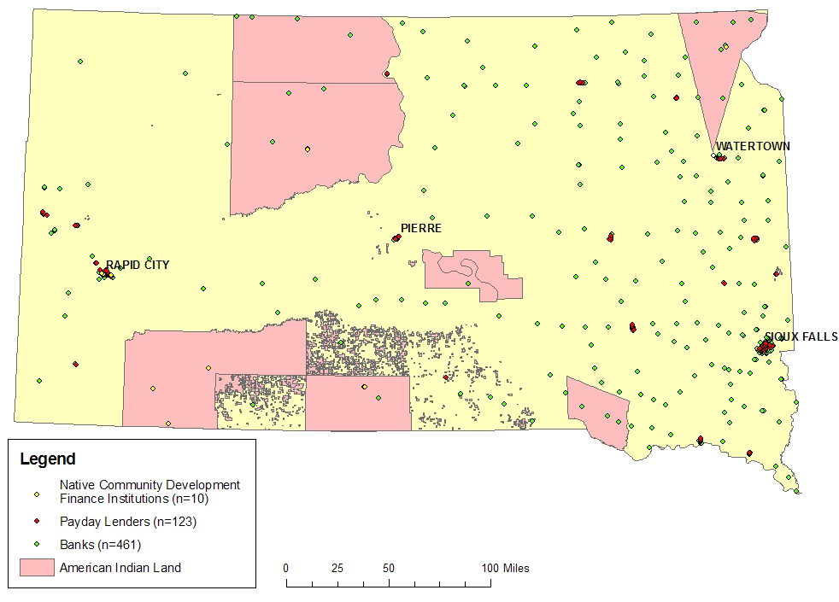

Sources: Payday lender data are from Steven Graves, compiled for Steven Graves and Christopher Peterson, “Usury Law and the Christian Right: Faith-Based Political Power and the Geography of American Payday Loan Regulation,” Catholic University Law Review 57(3): forthcoming; bank branch data are from the Federal Deposit Insurance Corporation database on full-service bank branches, available at http://www2.fdic.gov/sod/index.asp, accessed 16 April 2007.

Figure 2: Distribution of Predatory Lenders & Banks: Gallup, NM
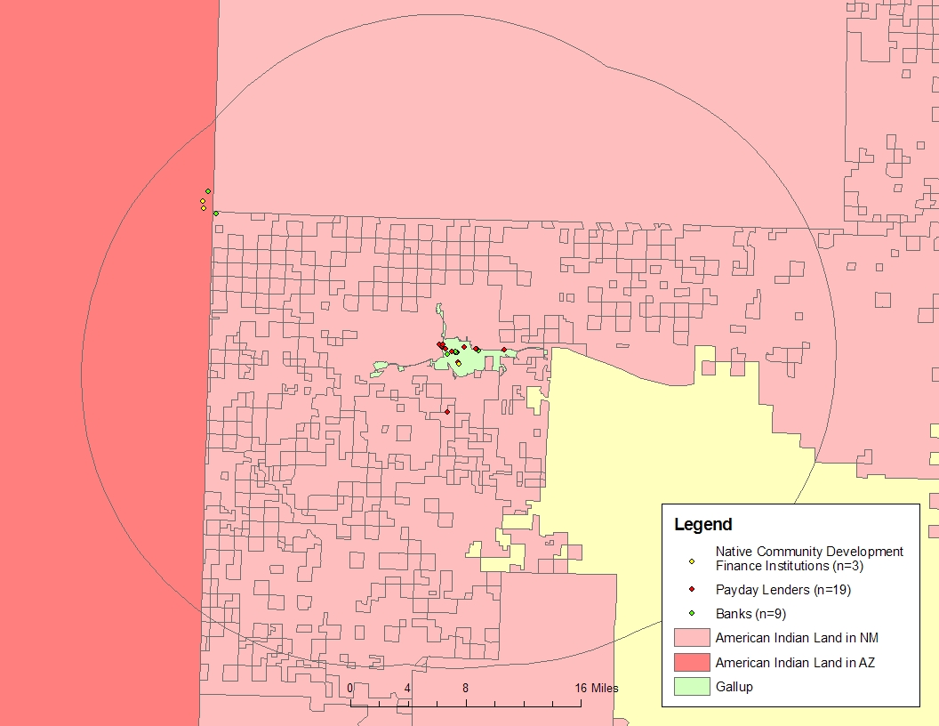
Sources: Payday lender data are from Steven Graves, compiled for Steven Graves and Christopher Peterson, “Usury Law and the Christian Right: Faith-Based Political Power and the Geography of American Payday Loan Regulation,” Catholic University Law Review 57(3): forthcoming; bank branch data are from the Federal Deposit Insurance Corporation database on full-service bank branches, available at http://www2.fdic.gov/sod/index.asp, accessed 16 April 2007.
Notes: A buffer is a tool used in ArcGIS to specify an area within a set distance around a particular feature; here the feature is the city of Gallup. Counts (n values) are of payday lenders and banks within the buffers.

