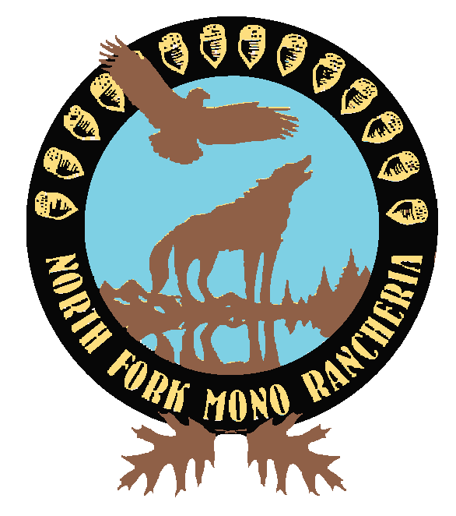

Submitted by Ms. Jacquie Davis Van Huss, Chairperson,
North Fork Rancheria of Mono Indians of California

Good morning Chairman Dorgan, Vice Chairman Murkowski and distinguished members of the Senate Committee on Indian Affairs.

My name is Jacquie Davis Van Huss and I am Chairperson of the North Fork Rancheria of Mono Indians of California, which is the largest restored tribe in California. Joining me today is our Vice-Chairperson Elaine Fink and our Secretary Katrina Lewis. I am delighted and honored to be here for several reasons. I am privileged to bring you greetings from each of our 1680 tribal citizens who share their immense pride today as I come forward to introduce and express support for and confidence in one of our enrolled Tribal citizens, Robert G. McSwain, or “Bob” as we know and love him.

For nearly three years Bob has proven himself at the highest levels of leadership at the Indian Health Services, first as IHS Deputy Director then as Acting IHS Director. His nomination now to be permanent Director of the Indian Health Services serves as both tribute and testimony to his capabilities and to his commitment to improve the health conditions of all American Indians.

Mr. Mike Leavitt, Secretary of Health and Human Services, had the following to say about Bob upon the assumption of his current role as Acting Director in September, 2007:

“I am pleased that Bob has taken on this position…. Over his 30-year career in the Department, Bob has played a pivotal role, most recently sharing responsibility with the IHS Director for managing a $4 billion national health care delivery program. His leadership has helped ensure that the IHS is able to provide top quality preventive, curative, and community care to approximately 1.9 million American Indians and Alaska Natives. During his tenure, Bob has received two Presidential Rank Awards for Distinguished and Meritorious service. I am confident he will continue to provide strong leadership for the IHS in serving as its Acting Director.”

The North Fork Rancheria takes health management seriously, having helped create and manage innovative programs such as a multi-tribal Temporary Assistance for Needy Families program and the multi-county Central Valley Indian Health, Incorporated. From this perspective, we too have full confidence in Bob’s ability to lead, manage, and advocate effectively on behalf of the nation’s American Indians and Alaska Natives in hospitals, clinics, and other settings throughout the United States.

The State of California is home to one fifth of the federally recognized tribal governments in the United States. Mr. Robert G. McSwain brings a unique perspective to this high federal position as both a native son of California and someone who has literally worked his way up to the highest levels of government. We believe this experience and perspective will serve Mr. McSwain well as he represents the diversity and richness of both American Indian health and tribal sovereignty concerns and needs.

We believe that Mr. Robert G. McSwain, our esteemed Tribal Citizen, will serve the position of Director of Indian Health Services with great honor and distinction.

With this said, I have the honor to introduce, our Tribal Citizen, Mr. Robert G. McSwain.

