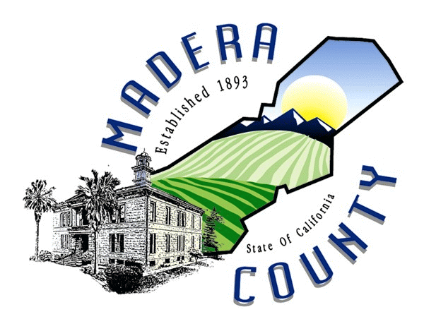

BOARD OF SUPERVISORS
COUNTY OF MADERA
MADERA COUNTY GOVERNMENT CENTER
200 WEST FOURHT STREET / MADERA, CALIFORNIA 93637
(559) 675-7700 / FAX (559) 673-3302 / TDD (559) 675-8970

FRANK BIGELOW
SUPERVISOR, DISTRICT 1

Frank Bigelow, District 1 Supervisor
Board of Supervisors, Madera County, California

Written Testimony

Before the Committee on Indian Affairs

United States Senate

OVERSIGHT HEARING on
Backlogs at the Department of the Interior:
Land into Trust Applications; Environmental Impact Statements;
Probate; Appraisals and Lease Approvals

October 4, 2007

Chairman Dorgan, distinguished members of the Committee, I appreciate the opportunity to be here today and to tell you how my community has been affected by the Department of the Interior’s nine-month delay in publishing a notice of availability of a draft environmental impact statement (“EIS”) for a tribal project in my county.

My name is Frank Bigelow and I have served on the Madera County Board of Supervisors for the past nine years. I am pleased to be here with Jacquie Davis-Van Huss, Tribal Chairperson of the North Fork Rancheria. On behalf of the County, I have worked closely with Jacquie and other tribal officials in connection with the Tribe’s efforts to have land taken into trust for a tribal gaming facility just outside of the City of Madera. The County of Madera, the City, and the Chambers of Commerce all strongly support this project.

As you know, the taking of lands into trust for a tribal gaming facility, is a major federal action under NEPA--the National Environmental Policy Act. As such, the Department of the Interior must comply with NEPA. As an elected County official, I believe that a key aspect of NEPA is that the lead agency--here the Department of the Interior--solicits and receives meaningful public input and comment on a proposed project in order for it to adequately assess the project’s impact on the environment.

The NEPA process allows impacted communities, such as mine, an opportunity to formally comment on a proposed project. Since the beginning stages of this project, we have been an active participant in this project--in fact, the City of Madera and the Madera Irrigation District are cooperating agencies for the EIS under NEPA. We have worked closely with the Tribe to ensure that all community concerns are addressed. The NEPA process facilitates this cooperation. We have benefited from this process and we want it to continue. We have also invested time and resources in this process. However, the process has stopped and we do not know why.

Please let me summarize the work that has gone into the preparation of the draft EIS for this project.

Three years ago the Bureau of Indian Affairs began preparing the draft EIS to examine the environmental impacts of the proposed project and various alternatives. The proposed project is located on a parcel which the Tribe had earlier identified in cooperation with the County and community representatives. The County considers the location ideal from an environmental, economic, and land use perspective, and thus, in August 2004, entered into a comprehensive Memorandum of Understanding with the Tribe to mitigate any possible impacts the project may have on the County.

Two months later, in October 2004, the BIA published a Notice of Intent to prepare an EIS for the project. The BIA then conducted a public hearing on the scoping process several weeks later, and eventually published the scoping report in July 2005. We participated in that hearing and were satisfied with the scoping report.

The BIA then worked diligently to prepare and distribute numerous administrative drafts of the EIS. In March 2006, the BIA sent an administrative draft EIS for review and comment to each of the five cooperating agencies, including the City of Madera and the Madera Irrigation District. These two local jurisdictions determined that the administrative draft provided more than enough information to use as a basis for negotiating their own separate mitigation agreements with the Tribe. In October 2006, the City entered into a Memorandum of Understanding with the Tribe, followed by the Madera Irrigation District two months later. Together with the County MOU, these agreements indicate the community’s strong support for the project. At this point, every Chamber of Commerce, the City of Chowchilla, and nearly every community organization in the County has endorsed the project.

I understand that the draft EIS was completed on February 2nd and that it was ready for distribution to the public. It is also my understanding that the draft EIS cannot be made public until there is a formal “Notice of Availability of the Draft EIS” published in the Federal Register.

Unfortunately, the Notice of Availability has not yet been published, even though the draft was completed over nine months ago. BIA officials have told the Tribe that the draft EIS is in order and nothing further is required from the Tribe for its publication. However, and despite the fact that the Tribe has repeatedly met with BIA representatives, and local government and community leaders have gone so far as to enlist the support of our local Congressional representative, the delay continues without explanation.

Let me stress that publication of the Notice of Availability in the Federal Register is not a decision on the merits of the Tribe’s project; it is simply a public notice of the draft EIS’s availability for review and comment. It is two pages in length and, as required by the BIA NEPA Handbook, contains a brief description of the proposed action and alternatives, instructions to the public for submitting comments and attending a public hearing, and a closing date for the receipt of comments. In short, it is a small but critical step to allow continued input from the public – including my constituents.

All levels of government have expended taxpayer dollars in the preparation and review of the draft EIS. Further delay in publishing the draft EIS would be unfair to taxpayers, since the environmental studies in the draft EIS may eventually need to be updated, triggering additional review. It is also unfair to the Tribe and its more than 1800 tribal citizens who continue to incur significant interest expenses with each passing month.

In closing, the County and City of Madera are excited about the Tribe’s project and the development that it has already brought to our community. We are hopeful that the Committee’s oversight will help end the current backlog so that the NEPA process can continue without further delay.

