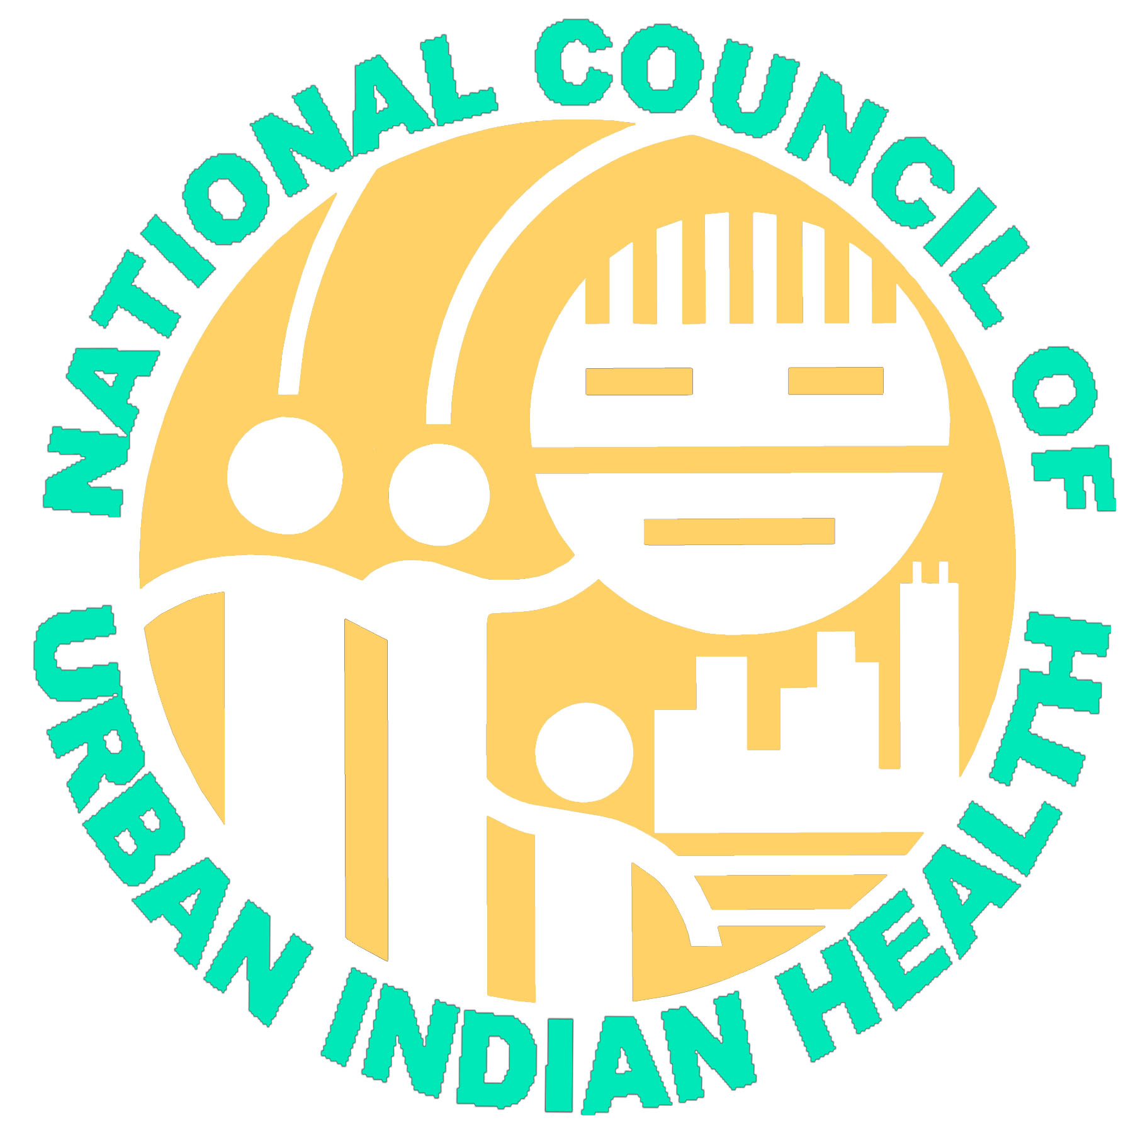
National Council of Urban Indian Health
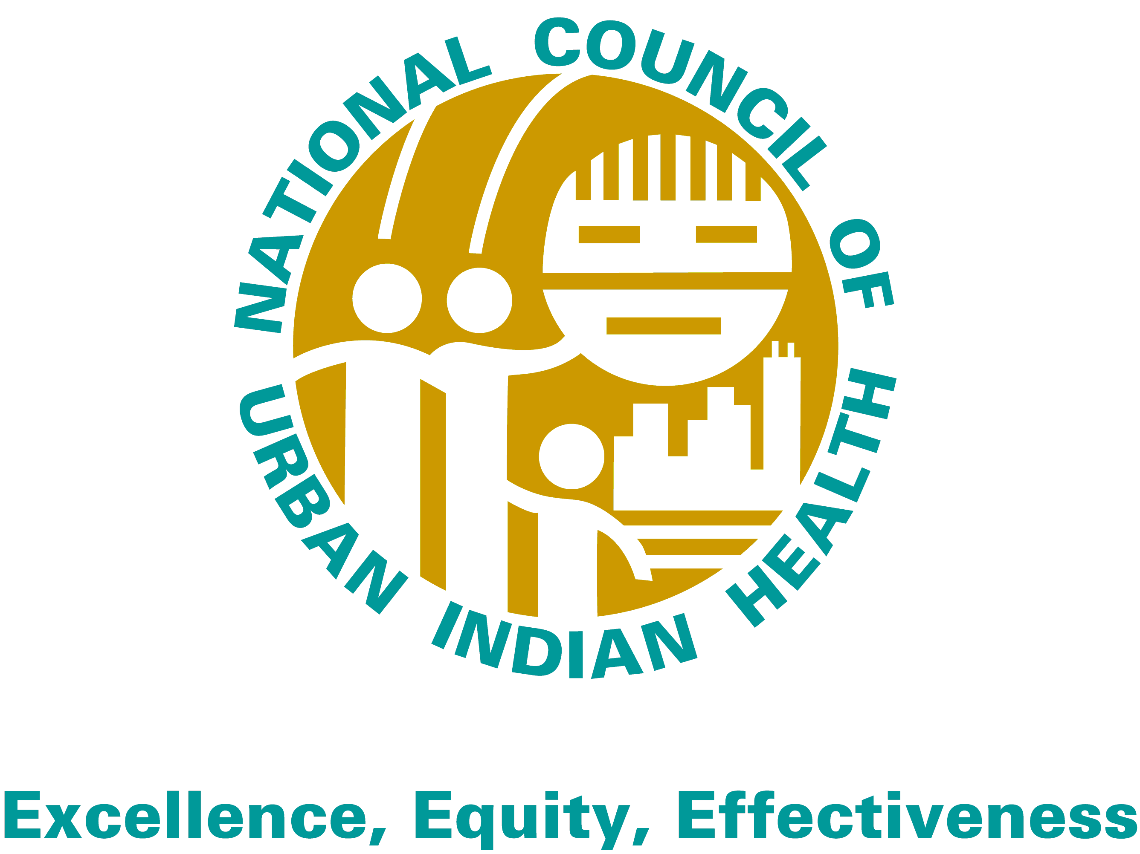
924 Pennsylvania Ave, SE Washington DC 20003
Office: 202-544-0344 Fax: 202-544-9394
www.ncuih.org

Testimony of
David Rambeau, President
National Council of Urban Indian Health before the
Senate Committee on Indian Affairs
Addressing “Advancing Indian Health Care”
February 5th, 2009

Introduction: Honorable Chairman and Committee Members, my name is David Rambeau. I am the president of the National Council of Urban Indian Health and the Executive Director of the United American Indian Involvement in Los Angeles California. On behalf of the NCUIH, our 36 member clinics, and the 150,000 American Indian/Alaska Native patients that we serve annually, I would like to thank the Senate Committee on Indian Affairs for this opportunity to testify on “Advancing Indian Health Care.” As we enter into not only a new Congress but also a new Administration it is critically important that reforming and improving the health care delivery system for Native Americans remains a high priority. I would like to thank Senator Dorgan, Senator Murkowski, and indeed the entire Senate Committee on Indian Affairs for all of their hard work on behalf of Indian health. It is my hope that in this new Congress that we can move forward on the critical issues facing the I/T/U system.
I am particularly honored and grateful to be able to present testimony for the nearly one million urban Indians. Congress has repeatedly stated that the trust responsibility to provide health care extends to Native Americans regardless of where they reside. The 2000 Census reported that over 60% of American Indians and Alaska Natives reside in urban centers and IHS estimates that roughly 930,000 of those living in those locations are eligible for services at Urban Indian Health Clinics. Our clinics are often the main, if not sole, source of health care for those communities. It is a small, but critical component in Native healthcare.
The UIHP provides an important link between reservations and urban centers as Native people move between the two. As one Federal court has noted, the “patterns of cross or circular migration on and off the reservations make it misleading to suggest that reservations and urban Indians are two well-defined groups.” Reservation and urban health services are deeply interconnected as we serve the same people and desire the best possible health outcomes for all Native peoples. The I/T/U system is precisely that, and integrated system serving the same group of patients as those patients move between their reservation homes and urban centers depending upon the demands of their lives. If one part of the system is damaged or performing poorly the entire system suffers, and more importantly the vulnerable patients who are dependent upon this system suffer.
It is critical that the Indian Health Care Improvement Act is passed this Congress in order to modernize and restore the I/T/U system; moreover, the entire I/T/U system must be fully funded from contract health to the Urban Indian Health Program. While NCUIH feels that Indian health organizations must be included in the larger debate around health care reform—and indeed Indian health providers have many sound suggestions for overall system reform—passing the Indian Health Care Improvement Act must be the priority for the 111th Congress. It has been over a decade since this important piece of legislation has been last reauthorized. While the Indian health delivery system certainly needs critical examination, that examination cannot come at the expense of passing the Indian Health Care Improvement Act.
Today I would like to offer suggestions and examples on the behalf of the Urban Indian Health Program, on how we can not only move forward with the Indian Health Care Improvement Act, but advance Indian health care in the context of comprehensive health care reform. We believe that the Indian Health Care Improvement Act is not the final say of health care reform for Indian people, but the first step in a larger discussion.

State of the Urban Indian Health Organization: I would like to give the Committee a brief overview of the incredible work that the clinics and programs of the UIHP have been doing. Despite the great obstacles facing them, urban Indian health organizations have had many great successes with both individual patients and in raising the entire wellness of the community. Many clinics are leaders in innovative health care delivery and community based medicine. UIHP clinics and programs are also seeing impressive health outcomes through the integration of traditional medicine practices with western medicine.
NCUIH firmly believes that health care reform must involve reform of the health care delivery system in the United States, not just reform of the insurance market. NCUIH feels that the Urban Indian Organizations and, indeed all Indian health programs, can be examples of how to reform health delivery in order to address health disparities. Urban Indian health organizations are particularly sensitive to changes in the general health care system as, due to their structure, they are far more integrated in state and local level health care systems. NCUIH, therefore, has been much more closely involved in state level health care reform initiatives and believes Indian health organizations have many areas where they could be leaders in changing how the general population conceives health care delivery.

Innovative Health Care Delivery: Urban Indian Organizations excel at developing innovative, culturally competent, efficient health care methods. Providing comprehensive care to Native Americans requires re-conceptualizing many western medical health delivery models in order to ensure that effective care is actually being provided. Cultural barriers for Native American patients, along with fiscal barriers, are the biggest continuing drivers of health disparities for American Indians and Alaska Natives living in urban centers. NCUIH strongly advocates for the aggressive reform of the current general health care delivery because the current delivery system fails to address soaring health disparities, chronic disease, and fails to provide preventative health services. The following examples are areas where the urban Indian health organizations are leading in innovation, and their lead should be followed in reforming the general health care delivery system.
NCUIH is working with the Urban Indian Organizations to develop a database to collect the best practices and disseminate them to not only other Urban Indian Organizations, but to any interested Indian health organizations. Often times Urban Indian health organizations are quiet leaders in innovative health delivery, but have not been able to adequately disseminate their successes due to their small size. Many Indian health organizations have developed best practices that are only now being identified and employed by the general health delivery system. If better communication between providers within the I/T/U system were available, and better communication between the Native health system and the general health system were also available, many of these models of care would have been disseminated much earlier.
Medical Home Model of Care: Long before the general health policy community coalesced behind the medical home mode of care the Urban Indian health organizations have been employing that theory of care. The American Academy of Family Physicians has called the patient-centered medical home model one of the single most powerful methods of eliminating racial and ethnic disparities in health care quality and access while improving care and management of chronic conditions for all patients. NARA of the Northwest in Portland Oregon has been following the medical home model for nearly two decades in both its inpatient residential treatment center and its medical clinic. More recently the Seattle Indian Health Board has worked with the University of Washington to develop a medical home model specific to the urban Indian health community.
Community Based Health Care: Urban Indian health organizations also have developed many community based approaches to health delivery. Working closely with community health workers and focusing on the wellness of the entire community, the San Jose and San Francisco programs have developed a number of outreach programs aimed at encouraging early preventative care that have resulted in increased diagnosis of pre-diabetic conditions and early heart disease. By focusing on the entire community and using the community member to community member model of health education, the San Jose and San Francisco programs have drastically reduced the levels of health disparity in diabetes diagnosis and treatment for their areas. Many urban Indian health programs have launched effective community based education and early detection programs that have dropped the rates of chronic disease in their community. Many programs are also developing Native American specific health communication tools so that Native American patients are better equipped to understand and communicate within our incredibly complex health care system. Moreover, by giving patients methods for translating their conception of their health and wellness into a language that non-Native providers can understand, the Urban Indian health programs are able to empower their patients to have better control over their health outcomes.
Traditional Medicine: Almost all urban Indian health programs involve traditional medicine practitioners in their health care delivery. By incorporating traditional medicine practitioners, UIOs are able to not only link patients to their community, but also help foster a sense of community and safety within the clinic itself. Integrating traditional medicine into the entire service delivery has resulted in many urban Indian health programs making a dramatic medical model shift away from the typical western model based around treating those in medical crisis, to a more wellness and preventative based approach. As stated earlier, the medical crisis model of care is particularly damaging to Native American patients and results in poor health outcomes and health disparities. Moreover, the inclusion of traditional medicine practitioners ensures the necessary cultural accessibility for Native American patients.

Impact of the Recession: Despite these great accomplishments the UIHP clinics and programs are feeling the impact of several years of short funding and the burgeoning recession. The UIHP is a fraction of the entire Indian health system operating at a little over 1% of the entire IHS budget. The clinics and programs of the UIHP have become adept at finding outside resources, leveraging every dollar of original IHS investment with two dollars from other sources. However, prolonged short funding of the UIHP has stretched UIHP resources to the breaking point. Programs are even more strained as the recession progresses which increases patient loads and reduces the availability of outside grants and resources.
Increased Patient Load: Many clinics are seeing increased patient visits due to the recession. As people lose their jobs and their regular health care provider, many are turning to the urban Indian health programs for health care. The Hunter Clinic in Wichita Kansas saw an increase of 1200 new patients in one month alone. Most clinics are reporting an increase of 25 to 100 new patient visits per month since the economic collapse in September. These figures are not static, but steadily increasing as the recession grinds on. Most Urban Indian health clinics were already working at full capacity and are struggling to provide services to the influx of new patients. Those programs in areas dependent upon single-source economies are particularly hard hit as people remain unemployed and uninsured for far longer. Clinics and programs are also seeing increased patient loads for social services such as food banks, unemployment support, and occupational education and training.
State Budget Crisis: As state budgets are forced to cut back due to the recession and the 2007 CMS regulation limiting federal reimbursement for outpatient clinics, many clinics are not receiving full or any reimbursement from state Medicaid plans for certain services. The urban Indian health organizations are particularly sensitive to changes in state and federal policy as they do not receive the OMB all inclusive rate for CMS reimbursement, nor do they have 100% of FMAP. Therefore, when state governments are forced to cut back on their Medicaid plans, Native American patients in urban centers suffer. If the Indian Health Care Improvement act had been passed prior to the start of the recession many of the urban Indian health programs would have been in a much stronger position and better equipped to deal with these issues.
Need for Expanded Services: Many clinics are also seeing increased patient demand for expanded services as other providers are increasingly refusing to serve Medicaid and Medicare patients due to low reimbursement rates. Patients are finding it increasingly difficult to access dental, optometric, and skilled nursing services. Either providers for these services are leaving the area (Montana and Nebraska) or non-Native providers are increasingly unwilling to take referrals from Urban Indian health programs (Kansas, Massachusetts, Washington) and patients are left without a provider for these critical services.

Conclusion: The Urban Indian health organizations are making impressive progress in combating health disparities and barriers to care for their Native American patients. However, many of these programs would have been in a better place to deal with the surge of new patients and patient demands caused by the recession if the Indian Health Care Improvement Act had been passed. In particular, the provisions increasing enrollment under Medicaid, Medicare, and SCHIP would have helped numerous patients access critically needed services. While a complete review of the I/T/U system within the context of health care reform is definitely necessary, such a review cannot delay the passage of the Indian Health Care Improvement Act. The Urban Indian Health Program is only a small part of the I/T/U system, but even this small part would have been significantly more stable during this economically uncertain time had the bill passed.

Urban Indians and the Indian Health Care Improvement Act: Passing the Indian Health Care Improvement Act and making serious progress on improving the health of all Native Americans is a priority for the Urban Indian Health Program. Our clinics and programs see patients from every tribe and every walk of life. Many of our patients would not seek care elsewhere due to problems of fiscal and cultural accessibility. As described above, the clinics and programs of the Urban Indian Health Program deliver innovative, culturally competent care despite funding shortfalls, the economic downturn, and active hostility from the previous Administration. However, NCUIH feels that UIHP would be in a much stronger position to deal with these issues had Congress successfully passed the Indian Health Care Improvement Act in the 110th Congress. Indeed, the entire I/T/U system desperately needs the modernization and increased capacity promised by the Indian Health Care Improvement Act.
The National Council of Urban Indian Health would like to outline those provisions which are particularly helpful for Urban Indian Organizations as well as describe provisions which have been lost in negotiations to the Bush Administration. NCUIH feels that the provisions lost in prior negotiations with the previous Administration could potentially be restored without delaying the passage of the entire bill. Indeed, NCUIH encourages the Senate Committee on Indian Affairs to complete all necessary work on the bill and introduce it within the next 180 days. NCUIH strongly feels that this administration and the focus on health care reform present a rare opportunity to pass the Indian Health Care Improvement Act this session.
Positive Provisions: The history of the Urban Indian Organizations within the Indian Health Care Improvement Act has often been fraught with peril. The inclusion of Title V—which authorizes the Urban Indian Health Program—has frequently been attacked and nearly successfully stripped from the bill entirely. Therefore, the simple inclusion of Title V without losing any of the authorities which currently exist under current law is considered a victory by most of the Urban Indian Organizations. While it is sad that the expectations of Urban Indian Organizations have been so reduced by years of negotiating away authorities and programs, it does speak to the tenacity of the programs, the support of Tribes, and the support of Congress that Title V yet endures. While the Indian Health Care Improvement Act of 2008 does not provide for many new authorities for the Urban Indian Health Program it did: 1) reaffirm the trust responsibility to urban Indians—a relationship that has been under attack for the past three years; 2) provided better outreach and enrollment in Medicaid, Medicare, and SCHIP for Native Americans, and; 3) provided increased competitive grant opportunities for the clinics and programs of the UIHPs. The provisions regarding Medicaid, Medicare, and SCHIP all would have helped the urban Indian health programs better deal with the sudden State budget deficits and resulting cut backs in State Medicaid reimbursements. Moreover, the Indian Health Care Improvement Act of 2008 would have helped stabilize tribal health programs, which would have in turn helped the Urban Indian Health Programs. When one of the pillars of the I/T/U system is damaged, the entire system shakes.
Conferring with Urban Indian Organizations: Although NCUIH and its member organizations do not have a government-to-government relationship with the federal government, and it would be appropriate to use the term ‘consult’ which has a special meaning in this context, the Urban Indian Organizations do represent Native Americans to whom a Trust responsibility is owed. Within the confines of that obligation, the federal government must make the effort to confer with those the urban Indian stakeholders.
Congress has consistently acknowledged the government’s trust responsibility extends to American Indians and Alaska Natives (AI/AN) living in urban settings. From the original Snyder act of 1921 to the Indian Health Care Improvement Act of 1976 and its Amendments, Congress has consistently found that: “The responsibility for the provision of health care, arising from treaties and laws that recognize this responsibility as an exchange for the cession of millions of acres of Indian land does not end at the borders of an Indian reservation. Rather, government relocation policies which designated certain urban areas as relocation centers for Indians, have in many instance forced Indian people who did not [want] to leave their reservations to relocate in urban areas, and the responsibility for the provision of health care services follows them there.” This trust responsibility includes, from the perspective of NCUIH, the obligation to confer with the Urban Indian community through their duly authorized representatives regarding how that trust responsibility is met. Given the soaring health disparities facing the Urban Indian population it is particularly necessary for meaningful discussion to take place in order for both the federal government and the Urban Indian health providers to ensure that the best possible care is provided to the vulnerable American Indian and Alaska Native community.
Inclusion of UIOs in Title II—Improvement of Indian Health Care Provided under the Social Security Act: The provisions contained in this Title would significantly help those programs currently billing Medicaid and Medicare and would help those programs who do not currently bill Medicaid and Medicare develop the capacity to do so. Third party reimbursements significantly stabilize the Urban Indian health programs that are capable of doing so. Expanded ability to seek reimbursement for medical services could mean the difference between providing certain key services such as dental and primary care and not being able to provide those services. When Urban Indian health programs are unable to provide services often times Native American patients simply will not seek care elsewhere, even if they are enrolled in Medicaid, Medicare or SCHIP. Provisions that are particularly important to the Urban Indian health programs are section 201 which amends section 1911 and section 1880 of the Social Security Act to include the Indian Health Service, Indian Tribes, Tribal organizations, and Urban Indian health programs as eligible entities. Currently Urban Indian health programs are treated as Federal Qualified Health Centers (FQHC) which are vulnerable to fluctuating reimbursement rates, particularly under the Medicaid program. NCUIH strongly encourages the Senate Committee on Indian Affairs to maintain Urban Indian Organizations in these provisions as it means the difference between fiscal stability and instability for many programs.
Section 509: Facilities: This provision provides for the Secretary to make grants to contractors for the “lease, purchase, renovation, construction or expansion of facilities, including leased facilities in order to assist such contractors or grant recipients in complying with applicable licensure or certification requirements.” This provision is very important to Urban Indian health programs as they are not currently eligible for facilities construction funding, though they currently have authority for facilities renovation. Many programs have construction projects that are necessary to maintain or expand services to their patient base. Unfortunately these programs do not currently have appropriations authority for construction projects and the private market for the large scale loans necessary for such projects has disappeared with the onset of the recession. NCUIH strongly encourages the Senate Committee on Indian Affairs to maintain this provision.

Provisions to be Reformed or Re-included: There are, of course, provisions that the National Council of Urban Indian Health would like to see reformed, or added; however, it is imperative that this act be passed in the 111th Congress. NCUIH urges the Senate Committee on Indian Affairs to consider re-including the Urban Indian health programs in the provisions listed below. These provisions deal with authorities and programs that are go to the core mission of the Urban Indian Health Program and directly address afflictions that are especially severe in the urban environment. Urban centers in particular have large patient populations with the very type of problems these programs address given the nature of living in an urban center where there is ready access to alcohol and a wider variety of illicit drugs. Moreover, Native Americans suffer additional stress in urban environments as they are separated from their community and surrounded by, in many respects, a foreign culture.
Many problems on the reservations are imported from urban locations because there is substantial movement back and forth between the reservation and Urban Indian communities. Tribal members with drug, alcohol and infectious diseases—like HIV/AIDs (which would be addressed under Section 212)—bring those illnesses back with them to the reservation. But that chain can – and has been – broken when they are treated at the urban center and always in a far more cost efficient manner then if the same patient receives significantly delayed care at an on-reservation IHS facility because they were forced to wait until they reached medical crisis and then return home. Urban Indian health programs form a critical link in preserving the health and viability of the Native American population by confronting many illnesses and substance abuse at their point of origin. The sad and fundamental truth is that eventually these patients must be seen and either they can be seen early, before the most destructive behaviors or illnesses set in, or they will be seen much later at the Tribal or IHS facility after the drug or alcohol abuse has destroyed their families or HIV/AIDS has gone untreated for months if not years and been spread to more individuals.
Section 701 Behavioral Health Prevention and Treatment Services—This provision provides grant, cooperative agreement, and contract opportunities for the development of comprehensive behavioral health prevention and treatment programs. This section also directs the Secretary to act through the Service, Tribes, Tribal Organizations, and previously Urban Indian Organizations, to develop plans to participate in developing area wide plans for Indian Behavioral Health Services.
Section 707(g) Indian Youth Program: Multidrug Abuse Program—this subsection directs the Secretary to provide programs and services to prevent and treat the abuse of multiple forms of substances through Tribes, Tribal Organizations, and previously Urban Indian Organizations.
Section 212 Prevention, Control, and Elimination of Communicable and Infectious Diseases—this provision provides grant opportunities to develop a variety of projects and programs to for the prevention, control and elimination of tuberculosis, hepatitis, HIV, respiratory syncytial virus, hanta virus, STDs and H. Pylori.

Conclusion: It is the first and foremost recommendation from the National Council of Urban Indian Health is that the Senate Committee on Indian Affairs move with all deliberate haste to complete our decade-long fight to reauthorize the Indian Health Care Improvement Act. The 110th Congress came achingly close to passing this critical act through the truly herculean efforts of yourself, Senator Dorgan and Senator Murkowski and the other members of this Committee. As stated before, this bill is not perfect but is the bill drafted through negotiation and compromise. The Chairman has requested that we take a fresh look at those areas where Tribal and urban Indian requests and provisions were dropped. NCUIH has included those areas that we hope the Committee continues to protect and those provisions that we hope the Committee will consider re-including. As members of the National Steering Committee, we will be working with other Indian advocates to review the entire bill. We will then work with our Tribal partner, NIHB, to vigorously advocate for these provisions.

Moving Indian Health Care Forward: As stated above, a quickly enacted IHCIA bill is the first vital step in moving all of Indian health forward. Once that step has been taken a full review of the entire Indian health care delivery system can begin. This would be an arduous, intensive process as it has been over fifty years since the Indian Health Service was created. It has been over thirty years since the original IHCIA was enacted creating not only the Urban Indian Health Program but many other Indian health programs. Health care delivery has significantly evolved in that time—and stands to significantly evolve yet again under the health care reform effort spearheaded by the Obama Administration. We hope that the critical review of the Indian health system will happen within the context of this reform effort so that the two efforts may inform each other. As stated earlier, it is critical that Indian issues are considered during the larger health care reform process, as many suggestions and best practices from Indian and Urban Indian health organizations could be put to good use in the larger context.
The National Council of Urban Indian Health believes that in order to move Indian health forward in the context of this reform effort we must be willing to take a cold, hard look at many of our programs and our conceptualization of health care delivery. We agree with the National Indian Health Board that it will require contribution of experts from both within and without the system, demand innovative ideas, and demand a willingness to challenge the current status quo. It will also take strength of will from both Congress and Indian leaders to see serious reform through to the end.

NCUIH offers the following recommendations for such a serious reform:
- Consult with all Indian people—tribal and urban. NCUIH strongly urges this Committee to seek out the opinions and thoughts of individual health care consumers, service providers, and tribal and urban leaders. Unless all Indian people are involved in this reform effort it will not reach all of the people that desperately need the I/T/U system to be running as the world-class system it could be.
- NCUIH strongly agrees with NIHB that any ‘solution’ that simply redistributes scarce existing resources is not a real solution. It only divides Native Americans against themselves and further damages the entire system of care for Native Americans.
- Conduct a needs assessment that includes the urban Indian health programs. It has been over twenty years since any needs assessment has taken the needs of urban Indians into account despite the fact that nearly 60% of the Native American population currently lives in urban centers.
- NCUIH also supports the NIHB suggestion that the Committee seek out Indian input through regional meetings, hearing and other potential mechanisms. NCUIH further urges the Committee to not forget Urban Indians in this effort.
- Serious reform must be accompanied by full funding of the I/T/U system to address unmet needs.
- Seek out and encourage the dissemination of Native American best practices. Our programs and clinics have been quiet leaders in innovative health care delivery for decades, but due to their small size have been unable to disseminate these best practices. Moreover, in order for the health disparities facing Native Americans to be seriously addressed best practices that actually work for Native people must be employed.

Conclusion: On behalf of the National Council of Urban Indian Health and the Urban Indian health organizations that we represent, I thank you for the opportunity to provide testimony and suggestions on how to advance Indian health care. NCUIH thanks the Committee for its support and dedication to Indian health. We have a rare moment with this Administration and this Congress to pass IHCIA and to pass it now without further delays or negotiations. NCUIH strongly urges the Committee to seize this moment and undertake comprehensive health care reform with Indian health in mind; pass the Indian Health Care Improvement Act; and initiate a comprehensive review of the Indian health care delivery system.

We are deeply grateful for your leadership and your commitment to improving Indian health, as we are grateful to all of the leaders who have come to give testimony today. We all have the same ultimate goal: ensure the best possible health care for our people.

I am available to answer any questions the Committee might have.

United States v. Raszkiewicz, 169 F.3d 459, 465 (7th Cir. 1999).
Somnath Saha, Mary Catherine Beach, Lisa Cooper, Patient Centeredness, Cultural Competence, and Healthcare Quality, Journal of the National Medical Association 2/2/2009 (calling for health care organizations and providers to adopt principles of both patient centeredness and cultural competence jointly.)
AAFP, “Medical Home Model Helps Eliminate Health Care Disparities.” 7/11/2007. http://www.aafp.org/online/en/home/publications/news/news-now/health-of-the-public/20070711commonwealthstudy.html Last accessed 1/30/2009; see also, The Commonwealth Fund, “Closing the Divide,” http://www.commonwealthfund.org/publications/publications_show.htm?doc_id=506814 last accessed 1/30/2008
Snyder Act, Public Law 67-85, November 2, 1921.
Senate Report 100-508, Indian Health Care Amendments of 1987, Sept 14, 1988, p25. Emphasis added
The Health Status of Urban American Indians and Alaska Natives, Urban Indian Health Institute. 2004; see also, Invisible Tribes: Urban Indians and Their Health in a Changing Worlds. Urban Indian Health Commission funded by the Robert Wood Johnson Foundation. 2007

