The Confederated Tribes of the Colville Reservation

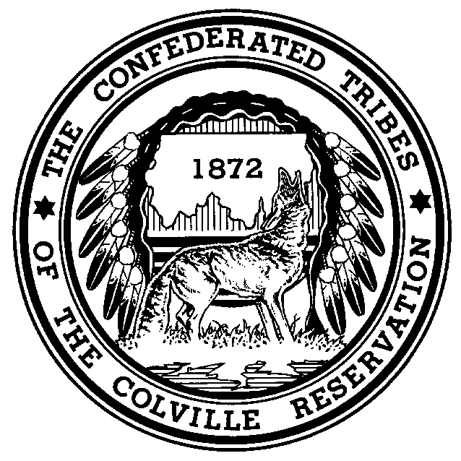

Prepared Statement of the Honorable John Sirois, Chairman

Confederated Tribes of the Colville Reservation

Senate Committee on Indian Affairs

Oversight Hearing on the President’s Fiscal Year 2014

Budget for Tribal Programs

April 24, 2013

Good afternoon Chairwoman Cantwell, Vice-Chairman Barrasso, and members of the Committee. On behalf of the Confederated Tribes of the Colville Reservation (“Colville Tribes” or the “CCT”), I appreciate the opportunity to testify today on the President’s FY 2014 budget request for Indian programs.

My testimony today will focus on economic development. Specifically, I have three recommendations for the Committee to consider as it reviews the FY 2014 request. The Colville Tribes consulted with the Affiliated Tribes of Northwest Indians (“ATNI”) in preparing this testimony to provide the Committee with a regional perspective on these issues.

**Background on the Colville Tribes**

First, I would like to provide some background on my people and our land. Although now considered a single Indian tribe, the Confederated Tribes of the Colville Reservation is, as the name states, a confederation of twelve aboriginal tribes and bands from all across the plateau region of the Northwest and extending into Canada. The present-day Colville Reservation encompasses approximately 1.4 million acres and is located in north-central Washington State. The Colville Tribes has more than 9,500 enrolled members, making it one of the largest Indian tribes in the Pacific Northwest. About half of the CCT’s members live on or near the Colville Reservation, which has more than 800,000 acres of forest land. Forestry and wood products have been the CCT’s traditional sources of revenue.

**The FY 2014 Request and Economic Development**

I want to acknowledge at the outset that almost every federal Indian program has historically been underfunded. The current budget climate and the imposition of sequestration for the current fiscal year have only made a bad situation worse. Unlike other federal spending, funding for Indian programs provides tangible services like health care, law enforcement, and housing to tribal communities. I believe I can speak for most tribal leaders when I say that prioritizing these activities is an impossible task because to rank one above another would imply that reductions to some Indian programs are somehow acceptable.

This is why facilitating economic development in Indian country should go hand in hand with protecting funding levels for Indian programs. Vigorous economic development and the creation of new jobs will empower Indian country to chart its own destiny. As the Congress evaluates the FY 2014 request, the Colville Tribes offers three recommendations:

(1) Increase Coordination between Federal Agencies to Maximize Program Resources and Appropriations

The federal government’s role in economic development in Indian country is not limited to Indian programs at the Department of the Interior (“DOI”). Many other federal agencies outside DOI have economic development programs and activities that tribes are eligible for or may otherwise participate in. Examples include the Office of Native American Programs (Department of Housing and Urban Development), Rural Development (Department of Agriculture), the Economic Development Administration (Department of Commerce), and several programs within the Department of Energy, to name a few.

Too often, however, these programs are underutilized by Indian country because they are decentralized, buried within other programs, or simply not effectively promoted. For example, the Bureau of Indian Affairs (“BIA”) administers the Indian Guaranteed Loan Program, a successful program that has allowed Indian tribes and Indian enterprises to obtain financing for commercial development. This program makes efficient use of its funds, with the demand for loan guarantees under this program routinely exceeding available appropriations. The FY 2014 request includes $5 million for this program, a $2 million *decrease* from FY 2012 enacted levels.

In contrast, the FY 2014 request includes $741 million for the Business and Industry Guaranteed Loan Program administered by USDA Rural Development. Indian tribes and tribal enterprises are among the entities eligible for loan guarantees under this program. Despite the high level of interest in the BIA Guaranteed Loan Program, this and other USDA programs are often overlooked because they are not considered “Indian” programs.

In the current budget climate, we believe that existing resources for economic development can be leveraged and maximized with more formal coordination between federal agencies. This type of coordination should also extend to other program activities that straddle different executive branch departments.

For example, there is a constant need for additional funding for the Criminal Investigations and Police Services account within the BIA’s budget, which funds tribal and BIA police officer salaries. There are occasions when there is only a single tribal officer on duty for the entire 1.4-million-acre Colville Reservation. Repeated requests by the Colville Tribes to renegotiate its law enforcement 638 contract with the BIA have been rejected because of the lack of additional base funding. We understand that the BIA and the Department of Justice have begun to communicate on these issues, and we are hopeful that these two agencies can coordinate their respective resources to ensure that as much money as possible from both departments is available for tribal officer salaries.

I would be remiss if I did not mention that, in the Colville Tribes’ view, DOI’s Office of Indian Energy and Economic Development (“OIEED”) has proven to be a positive example of a federal agency consolidating economic development functions in a single program. Over the years the Colville Tribes has utilized this program for technical assistance, grants, and capacity building as we have planned and developed renewable energy projects. The Colville Tribes is pleased to see that the FY 2014 request includes an increase for OIEED specifically for tribal energy development activities.

(2) Continue Promoting Legislation that Streamlines Administrative Processes and Eliminates Burdensome Regulations

Tribes face a number of barriers in persuading outside investors to do business in Indian country. As a result, Indian tribes in remote areas are often the largest employers in their geographic region. The Colville Tribes, together with our affiliated enterprises, are collectively one of the largest employers in north-central Washington State. Still, businesses are often hesitant to locate their operations on Indian lands because of the administrative burdens, both real and perceived, that accompany federal approval requirements applicable to many activities on Indian land.

Last year Congress enacted the HEARTH Act, which allows Indian tribes to develop tribal leasing regulations and to enter into leases with third parties under those regulations without the need for BIA approval. The HEARTH Act recognizes the policy of self-determination by respecting tribes and trusting their judgments on the types of leases they believe can be appropriately expedited and those that should proceed through the existing BIA approval process.

The HEARTH Act proceeded through this Committee and was the only Indian bill of general applicability to become law in the last Congress. This Committee can play a key role by continuing to promote legislation like the HEARTH Act that streamlines administrative processes and eliminates outdated requirements.

In that regard, the Colville Tribes is very encouraged that Chairwoman Cantwell and Vice-Chairman Barrasso are working to develop Indian energy legislation for re-introduction in this Congress. Last year the Colville Tribes and ATNI and its member tribes strongly supported S.1684, the *Indian Tribal Energy Development and Self-Determination Act Amendments of 2012*. We are particularly supportive of the Tribal Biomass Demonstration Project provisions, which could enable us to secure financing for a planned biomass facility on the Colville Reservation. We look forward to working with the Committee on this important legislation with an eye on enactment this calendar year.

(3) Structural Reforms as a Means to Promote Economic Development

As the Committee is aware, deliberations are underway in both chambers to overhaul the Internal Revenue Code (“IRC”). Indian tribes and individual Indians have much at stake in any broad tax reform initiative. For example, various provisions of the IRC fail to treat Indian tribes like other governments, such as providing the ability to issue tax-exempt bonds to the same extent that state and local governments can.

Other IRC provisions valued by the private sector need to be made permanent to improve their usefulness. The accelerated depreciation and Indian employment tax credit provisions are examples of IRC provisions that are underutilized because Congress extends them only on a year-to-year basis, if at all. Quite simply, because a would-be investor cannot count on these provisions being renewed prior to a deal closing, they are simply not factored into a given transaction. We encourage this Committee to collaborate with the Senate Finance Committee and other committees of jurisdiction and to advocate for these and other tax provisions that will encourage investment in Indian country.

Apart from taxation, there are other structural reforms that would promote economic development. One of them is the *Indian Trust Asset Reform Act of 2013* (S.165, and its House counterpart, H.R. 409), which was introduced by Senator Mike Crapo and has been referred to this Committee. This bill would establish a voluntary mechanism for Indian tribes to prioritize the management and funding of their trust assets. It would authorize Indian tribes with natural resources like timber and agriculture to direct the management of these resources to achieve tribally focused objectives. These objectives might include managing forests in a manner to maximize fair market value or, on the other hand, rendering forested areas off-limits to encourage off-reservation tourism. Most of the text of S.165 was drafted by this Committee’s staff in the 109th Congress after extensive outreach to Indian country. The ATNI Trust Reform Committee updated the bill last fall and ATNI enacted a resolution endorsing it at its 2012 annual conference. We hope the Committee will swiftly take it up in the weeks ahead.

I appreciate the Committee’s consideration of this testimony and the Colville Tribes looks forward to working with the Committee on these and other issues. At this time I would be happy to answer any questions the members of the Committee may have.

***