Testimony of
Kevin K. Washburn
Assistant Secretary – Indian Affairs
United States Department of the Interior
Before The
Senate Committee on Indian Affairs
Oversight Hearing
On
"Wildfires and Forest Management: Prevention is Preservation"

May 14, 2014

Good afternoon Chairman Tester, Vice Chairman Barrasso, and members of the Committee. Thank you for inviting the Department of the Interior (Department) to provide testimony about tribal forestry and wildland fire management. Forests encompass about a third of the total Indian trust lands and provide irreplaceable economic and cultural benefits to Indian people. Forests store and filter the water and purify the air. They sustain habitats for the fish and wildlife that provide sustenance for the people. They produce foods, medicines, fuel, and materials for shelter, transportation, and artistic expression. Forests provide revenues for many tribal governments and in some cases provide the principal source of revenue for a tribal government and provide employment for Indian people in these rural communities.

Overview

There are over 18 million acres of Indian forests in the U.S. held in trust by the federal government. There are 310 forested Indian reservations located in 24 states. Six million acres are considered commercial timberlands, nearly four million acres are commercial woodlands, and more than eight million acres are a mixture of noncommercial timberlands and woodlands. Commercial forests on trust land are producing nearly one billion board feet of merchantable timber every year.

Historically, the management of tribal land was accomplished through the use of fire. Today however, fire alone cannot be used to accomplish forest management activities. The management of Indian forests and other resources is limited by geographic and political boundaries and increasingly threatened from external forces, such as wildfire, insects, disease, development and urbanization.

Forests on tribal reservations and throughout the country, but particularly in the more arid interior west, have grown much denser in recent decades, have undergone shifts in species composition, and have experienced more frequent epidemics of insect and disease infestations. These conditions are considered indicators of poor forest health and jeopardize tribal forest resources. Left untreated, forests in poor condition pose a threat of catastrophic loss by wildfire. Maintaining healthy, productive tribal forests requires the cutting and sale of large trees as well as the thinning of small trees through mechanical and prescribed fire methods.

Timber Management – Thinning the Large Trees

Our professional foresters and fire managers who work for the Bureau of Indian Affairs and for Tribal programs understand the art and science of maintaining forest health, as well as the need to incorporate Tribal goals, objectives and traditional ecological knowledge. However, there are various limitations to the amount of work these dedicated land managers can perform, including the absence of viable forest products markets, milling infrastructure, and resources for post-harvest thinning, burning, and planting.
Since 2003, timber harvest levels have dropped 42%, from 635.4 to 367.9 million board feet. Tribes are now harvesting only 38% of what is currently available to be harvested on an annual, sustained yield basis. By not harvesting what is growing annually, the forests continue to get denser. It is important to note that these larger trees are not being removed through the Bureau’s Forest Development program or the Department’s Fuels Management program and contrary to common belief, the large tree component of the forest often sustains catastrophic stand replacement crown fire.

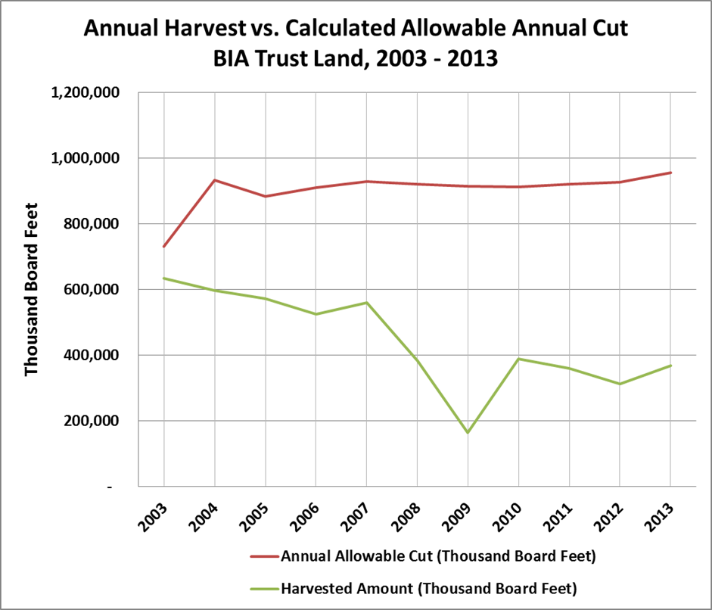

Tribes which actively manage timber and other forest products rely on sale proceeds to employ tribal members, finance economic development projects and tribal infrastructure, and provide social services.

Tribes have begun coordinating and collaborating with their federal and state partners on a regional basis to identify ways marketable forest wood fiber supply can be pooled in an effort to entice industry to finance regional milling and biomass utilization converting facilities, through what is known as the Anchor Forest Initiative. As a stand-alone supplier, most tribes lack the amount of wood fiber necessary to support the capitalization of converting facilities that utilize forest-based fiber. The maintenance of a healthy forest products economy and strategically located regional processing facilities promotes long term forest health and helps to prevent catastrophic wildfire. The Department supports concepts such as the Anchor Forest Initiative and is working with the Tribes, the Bureau of Indian Affairs, and the Department of Agriculture in nurturing this initiative.

Forest Development and Fuels Management – Thinning Small Trees and Treating Dead Fuels

Investments in pre-commercial thinning and hazardous fuels reduction operations keep forests healthy and resilient, helping avoid stand-replacing crown fires and associated environmental and economic consequences, including pollution to the atmosphere.

The Bureau of Indian Affairs funds project work for thinning excess small trees while the Department, through the Wildland Fire Management Appropriation, funds hazardous fuels treatments which reduce both dead and live fuels. These funding sources complement one another and are often strategically comingled in order to meet silvicultural prescriptions. From 2003 to 2013, the BIA has treated an average of 31,430 acres annually, using funding appropriated through the BIA’s Forestry Subactivity. During this same period, an average of 210,746 acres annually has been treated using funding appropriated through the Department’s Wildland Fire Appropriation.
In many tribal forests, treatments which include both the harvesting (sale) of large trees and the removal of excess small trees must be combined in order to ensure treatments are comprehensive and meet science-based silvicultural prescriptions. A comprehensive treatment is the most effective way to ensure the forest stays healthy, free of infestation and disease, while being resilient to the effects of unwanted wildfire.

National Indian Forest Resources Management Act (NIFRMA)

In 1991, the Department supported enactment of the National Indian Forest Resources Management Act (NIFRMA). The Act authorized the Secretary to conduct a comparative analysis of investments made in Indian Forestry, versus those made in other land management agencies, every ten years (25 USC Sec. 3111). This periodic assessment is known as the Indian Forest Management Assessment (IFMAT).

The IFMAT Report

The IFMAT Report addresses eight required NIFRMA evaluation criteria which include:
- an in-depth analysis of management practices on, and the level of funding for, specific Indian forest land compared with similar Federal and private forest lands,
- a survey of the condition of Indian forest lands, including health and productivity levels,
- an evaluation of the staffing patterns of forestry organizations of the Bureau of Indian Affairs and of Indian tribes,
- an evaluation of procedures employed in timber sales administration, including preparation, field supervision, and accountability for proceeds,
- an analysis of the potential for reducing or eliminating relevant administrative procedures, rules and policies of the Bureau of Indian Affairs consistent with the Federal trust responsibility,
- a comprehensive review of the adequacy of Indian forest land management plans, including their compatibility with applicable tribal integrated resource management plans and their ability to meet tribal needs and priorities,
- an evaluation of the feasibility and desirability of establishing minimum standards against which the adequacy of the forestry programs of the Bureau of Indian Affairs in fulfilling its trust responsibility to Indian tribes can be measured, and
- a recommendation of any reforms and increased funding levels necessary to bring Indian forest land management programs to a state-of-the-art condition.

The third IFMAT report was recently completed in 2013. The report found that tribes are assuming an ever-increasing leadership role in forest management activities through self-determination and self-governance, with 38 percent of the 310 Indian forestry programs nation-wide currently managed by the Tribes. I am proud to say that the report found that both Bureau of Indian Affairs and tribal forest managers rank as some of the most dedicated, hardworking individuals in the forest management profession. Their innovation and influence on the science of integrated forestry practices and sustained yield management is widely recognized, providing a solution for ecosystem health and productivity and a framework for cross-jurisdictional management of federal and state lands through the Anchor Forest Initiative.

The IFMAT team visited 20 Indian reservations and received input from Bureau of Indian Affairs (BIA) and tribal foresters and resource managers, forestry students, tribal leaders, and tribal elders. The reservations, forests, and people visited were highly diverse, each with their own set of local challenges. It was broadly noted by respondents that Indian forests are increasingly threatened by external forces, such as wildfire, insects, disease, development, climate change, declining access to markets, and urbanization.

The Report showed many positive examples of people caring deeply about the land and their management decisions. Indian forests represent a unique window into the interaction between forests and people.

The management of Indian forests must be directed toward achieving a dynamic set of tribal objectives, making the management of Indian forestlands particularly unique. Tribal leaders have recently begun extending their influence beyond reservation boundaries to build interagency partnerships for a sustainable future. Tribes with permanent land bases and a demonstrated history of long-term stewardship play a pivotal role to achieve cross-boundary, landscape-level resource management and restoration.

Current Department Initiatives

There are many opportunities to build on the findings and recommendations of the IFMAT Report. The groundwork has already been laid through FY14 Forestry program initiatives that include additional support to tribes to maintain productive levels of forest management. In addition, as part of the Administration’s commitment to advance science-based collaborative efforts, we have provided for climate change research and the development of a youth program in forestry.

We are particularly pleased with our Youth Initiative which supports the development of tribal youth engaged in projects that promote climate change awareness. This program, in partnership with a tribal college, will provide opportunities for youth to gain hands-on classroom and field experience in the field of forestry and study the relationship to climate change and the long term implications to tribal forestry. Furthermore, the college currently sponsors 14 cooperative education students who are receiving Forestry education at universities throughout the country. Our goal is to increase the number of students enrolled in this program by FY16, which provides tuition and other support, as qualified entry level American Indian and Alaska Native foresters are in short supply.

Conclusion

Thank you for the opportunity to provide the Department’s views. The Department continues to work with Tribes to promote healthy forests and will continue to work closely with this Committee as well as our federal and state partners to address forestry and fire management issues

Thank you for focusing attention on this important topic. I am available to answer any questions the Committee may have.

