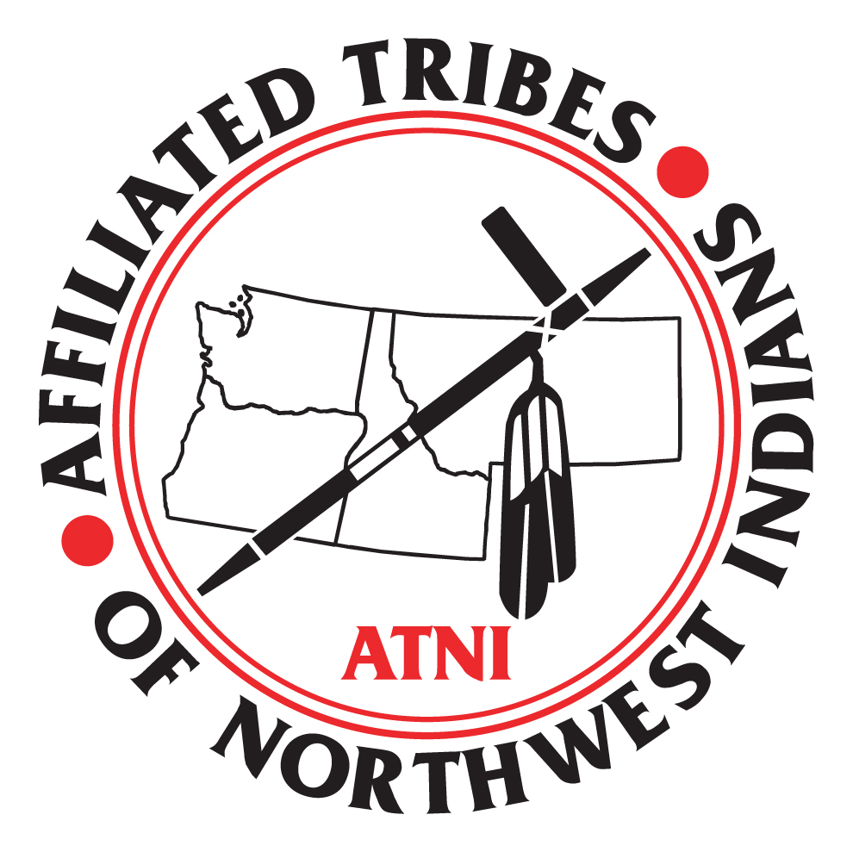

Affiliated Tribes of Northwest Indians

Testimony of James Steele Jr.
First Vice-President, Affiliated Tribes of Northwest Indians

OVERSIGHT HEARING on the President's Fiscal Year 2012 Budget
for Tribal Programs

Tuesday, March 15 2011
10:00AM
Dirksen-628

Senate Committee on Indian Affairs

March 15, 2011
______________________________________________________________________

Good morning Chairman Daniel Kahinina and Committee members. First, I would like to congratulate Senator Daniel Kahikina Akaka as the new Chairman of the Senate Indian Affairs Committee. On behalf of the northwest region we deeply respect and honor your leadership as America’s first Senator of Native Hawaiian ancestry, and the only Chinese American member of the United States Senate.

My name is James Steele, I am the First Vice-President of the Affiliated Tribes of Northwest Indians (“ATNI”) and the serve as councilman to the Confederated Salish and Kootenai Tribes of the Flathead Nation in Montana State. ATNI appreciates the opportunity to testify on the President's Fiscal Year 2012 Budget for Tribal Programs affecting Indian tribes in the northwest.

Founded in 1953, ATNI represents 57 tribal governments from Oregon, Idaho, Washington, western Montana, Alaska, northern California, and Nevada. Today, I am proud to be able to highlight for the Committee some issues affecting northwest tribes. The northwest tribes are very diverse. The northwest is home to tribes with large reservations and natural resource based economies and others with very little, if any, land. Despite our ranging differences northwest tribes stand strong together under ATNI to face the challenges of ensuring our communities are healthy, safe and sustainable.

Today’s hearing provides us an opportunity to share recommendations for programs that flow through the President's Fiscal Year 2012 Budget. Our deliberations today will not only share our top three priorities for the Self Governance Budget that is presently being discussed by the Tribal Interior Budget Council (TIBC) this week but we will also expand our discussion today to include how the budget and actions of this Congress will impact our capacity to fully address unmet needs to improve governmental services and economic development.

Let me start with a few thoughts that have guided the leadership for the northwest tribes. Our region, like many others, has diverse economies that consist of natural resources in salmon, timber and agriculture; gaming tribes with small and large venues; business ventures that stretch from 8a contracts to the ports in the northwest and most recently the investment and infrastructure building for renewable energy.

We, as northwest tribes, are learning more as we progress. We have learned that distributing income from casinos is not the answer. Indeed, just as would be imagined for any other community, free, windfall money is more likely to reduce motivation, destroy self-esteem, and aggravates the long endured and reinforced symptoms of poverty than it is to solve them. We have learned that job creation alone is not the solution. People accustomed to living outdoors, to whom hunting and fishing remain among the most valued possible human endeavors aren’t necessarily drawn to windowless, smoke filed rooms lit with flashing lights or corporate style offices.

Gaming has enabled many northwest tribes to provide basic health care, education, and housing. We address many of those by-products of poverty with childcare, provide for law and justice, care for the elders, and drug and alcohol programs. We provide these social services not only to ourselves, but to our neighbors as well. In many cases, we are the only providers of these services and make them available to surrounding communities.

Increasingly, the northwest tribes have been leaders in assuming direct managing of our natural resources. According to Bureau of Indian Affairs statistics, the northwest tribes and their enterprises support 40,000 jobs and buy over a billion dollars a year in supplies and services, much of which supports our larger local communities. We deliver a full range of government services of a complexity unsurpassed in the US except by the federal government. And we operate businesses of a size and scale on par with almost any private business. Yet we typically do so with the human resources of a small town. The largest Tribes in our region seldom exceed 10,000 in total population and smallest tribes go as low as 700 in population.

With these observations in mind, below are some issues, concerns, and opportunities that ATNI sees with respect to economic and social issues for its membership. Let me start with the Self Governance Legislative and Budget needs for 2012. As we all know there are many answers that begin and end with the Department of Interior and the Office of Self Governance. Today I will share a few top priorities and goals, as you will be receiving more outcomes from the TBIC, which is meeting in DC throughout the week.

Expanding Self Determination and Self Governance opportunities is a key to the future of many ATNI Tribes. Many ATNI Tribes seek to continue to restore their resources so that they can once again be contributors to their spiritual, physical, and economic health. We ask that the federal government actively pursue with us our lead role under the directives of the Indian Self Determination Act (PL 93-638). This would include making the policy of self-determination a proactive element of the Congress and the Federal Government, not just a consequence of the Tribes’ insistence. In order for Self Governance tribes to be successful they need the full support and cooperation of their regional office. We want to thank our regional director, Stanley Speaks for assisting our member tribes to take full advantage of the Indian Self Determination Act (PL 93-638).

Background on Self Governance Budget

Self-Governance is a tribally-driven, congressional legislative option, whereby tribal governments are authorized to negotiate annual appropriated funding and assume management and control of programs, services, functions and activities (or portions thereof) that were previously managed by the federal government. Self-Governance represents the expansion and growth of the historical legislation, P.L. 93-638, the Indian Self-Determination and Education Assistance Act (ISDEAA), in that it allows tribes, as sovereign nations, to exercise their right to be self-governing and to take program funds and manage them to best fit the needs of their citizens and tribal communities.

Since initiation of the first Self-Governance agreement more than two decades ago, the number of Tribes and the amount of programs and funding managed under this legislation has steadily increased. As of 2011, there are 260 Self-Governance (SG) Tribes within the Department of the Interior – Indian Affairs – Office of Self-Governance (DOI-IA-OSG). There are 104 compacts funded through 104 annual funding agreements totaling $450 million. Within the Department of Health and Human Services - Indian Health Service – Office of Tribal Self-Governance (DHHS –IHS-OTSG), there are 78 Title V compacts, funded through 100 Funding Agreements, totaling approximately $1.4 billion. These compacts represent 332 Tribes − more than half of all the federally recognized Tribes. Throughout this period, the Self-Governance Tribal leadership and representatives have held on-going meetings with the Administration and Congress to discuss how to improve and advance Self-Governance. Further, the Self-Governance Tribes conduct an Annual Conference and meet each fall for a Strategic Planning Session to discuss and identify goals and priorities.

Established in 1994, the DOI Self-Governance Advisory Committee (SGAC) provides information and advice to the Assistant Secretary-Indian Affairs and the Director of the Office of Self-Governance (OSG) regarding all Self-Governance programs, federal laws, regulations, policies and budget issues within Indian Affairs.

Established in 1996, the Tribal Self-Governance Advisory Committee (TSGAC) provides information dissemination, education, advocacy and policy guidance for implementation of Self-Governance within the Indian Health Service. The passage of Title V, The Tribal Self-Governance Amendments of 2000 (P.L. 106-260) and the subsequent promulgation of the Title V regulations, published in the Federal Register on May 17, 2002, further strengthen the role of the TSGAC in implementing this Act.
Self-Governance Tribes are doing a great job as managers and administrators of programs on and off the reservation. We are the most qualified to share best practices and to guide the future of Self-Governance. The physical and mental health of our people has improved under Self-Governance and will continue to do so as long as we are allowed to operate programs as we deem appropriate and most beneficial to our local communities and Tribal citizens. Department of the Interior & Indian Affairs Policy, Budget and Legislative Priorities: Goals, Strategies and Actions

BUDGET PRIORITIES

Self Governance: Top Three Budget Goals

Goal #1: Restore Self-Governance Base Budgets, Protect from Further Erosion and Provide Equitable Funding

Goal #2:
Fully fund Contract Support Costs (CSC)

Goal #3:
Provide Funding Increase for Tribal Priority Allocations, Public Safety and Justice, Indian Reservation Roads, and Education Programs

Detailed Information for Goal’s listed below:

Goal #1: Restore Self-Governance Base Budgets, Protect from Further Erosion and Provide Equitable Funding

Faulty budget decision making occurs in two predominant variations. First, the lack of data results in the application of existing funding formulas without accurate, consistent and verifiable formula variables. Without accurate data, funding formulas have the appearance of fairness and objectivity while masking the underlying inequities embedded within the distribution. The application of the Indian Reservation Roads (IRR) formula is one such example. While the IRR formula attempts to provide a fair distribution of funds using the variables of population, cost to construct, and vehicle miles traveled, data inaccuracies regarding Tribal road inventories and the condition of the roads therein, leads to inequitable funding distributions. Formula variables must be supported by data that is readily obtainable, quantifiable, and verifiable.

The second variation of faulty budget decision making occurs when there is simply no objectively defined funding distribution formula at all. Without a defined funding formula, BIA personnel make allocation decisions based upon personal knowledge and preferences. For example, in the Law Enforcement Program, BIA personnel make funding allocation decisions based upon personal knowledge of Tribal needs. This knowledge is obtained inconsistently and idiosyncratically and too often relies almost exclusively on who knows whom and results in decisions that cannot be reasonably predicted or justified.

Another strategy utilized by the Agency for the distribution of funds without a clearly defined formula, is prioritizing need on the individual recipient basis rather than at the Tribal level. Such is the case with the Housing Improvement Program (HIP). The allocation of funds from Central Office to respective Tribes is not efficient or effective. Tribal distributions have the advantage of strengthening and empowering Tribal governments while allowing for more accurate and timely decision making at the local level.

While the development and consistent application of clearly defined funding formulas could maximize program service delivery throughout Indian Country, the most logical solution to this problem is to identify those programs that have been arbitrarily removed from Tribal administration (Law Enforcement, Housing Improvement Program, General Assistance, etc.) and return them to the Tribal Priority Allocations (TPA) account. It has been demonstrated time and time again, that programs administered at the local level are more efficient and effective in meeting the identified needs of Tribal communities.

Goal #2:
Fully fund Contract Support Costs (CSC)

The lack of CSC dollars diminishes the administrative capacity of Indian Tribes to deliver quality programs and services to our members. It undermines our ability to recruit, train, and retain qualified, professional employees. The Tribal administrative personnel hired with CSC dollars help ensure accountability and transparency in our administration of federal programs. Contract support cost shortfalls force Tribal governments to subsidize those costs by using program funds or tribal dollars. The Indian Self-Determination and Education Assistance Act (ISDEAA), Public Law 93-638, mandates that Indian Tribes be paid full contract support costs. There is no other government contractor that is forced to subsidize federal contracts. The consistent failure to pay full contract support costs results in a de facto moratorium on Self-Determination and Self-Governance compacting while penalizing Tribes in the exercise of their Self-Determination rights under the law.

Goal #3:
Provide Funding Increase for Tribal Priority Allocations, Public Safety and Justice, Indian Reservation Roads, and Education Programs

Tribal Priority Allocations (TPA)
TPA is one of the most important funding areas for Tribal governments. It covers such needs as economic development, general assistance, and natural resource management. Since Tribes have the flexibility to use TPA funds to meet the unique needs of their individual communities, these are the main resources for Tribes to exercise their powers of Self-Governance. However, from 1998 through 2004, BIA’s funding for Tribal Priority Allocations declined from 42% of BIA’s budget to only 33.3%. In 2000, TPA funding was so inadequate that the estimated need was $2.8 billion. According to the budget statistics compiled by the National Congress of American Indians (NCAI), inadequate TPA funding reaches back two decades and has prevented Tribes from fully exercising Self-Governance.

Tribal Public Safety and Justice Programs
Tribal governments, through Tribal law enforcement agencies, are the front line for crime control and prevention in Indian Country. According to the BIA, Indian Country has a 42% unmet staffing need for police departments. Most Indian communities have 2-3 officers charged with patrolling an area the size of Delaware (2044 square miles). This severe understaffing contributes to an unacceptable high crime rate: 1 in 10 American Indians become victims of violent crime annually and 1 in 3 Indian women will be raped in her lifetime. To make matters even worse, more often than not, U.S. Attorneys decline to prosecute cases originating in Indian Country.

Indian Reservation Roads (IRR)
Interior Department officials have recognized that transportation systems serving Tribal communities suffer from a nearly $40 billion construction backlog. Although Tribal roads represent 9.18% of the combined total of federal-aid for highways and federally owned roads, the IRR program receives only 1.4% of funds authorized to be appropriated under Title I of the Safe, Accountable, Flexible Transportation Equity Act – A Legacy for Users (SAFETEA-LU). Tribes with significant acreage have the most backlog which significantly impacts safety.

Tribal Education Programs
Native American children lag significantly behind the general population in educational attainment. For example, Native people are twice as likely to have less than a ninth-grade education and only 12% of American Indians residing on reservations have college degrees compared to over 30% for the entire U.S. population. Effective and culturally relevant education is critical for nurturing strong, prosperous Tribal youth and laying the foundation for healthy communities. Without significant resources to develop effective educational programs, tribes in the northwest are opening their own schools and funding the needs from tribal taxed revenue dollars.

Renewable Energy Development and Climate Change: ATNI member tribes are very interested in energy development because it is a key to economic development for many northwest Tribes, many of which are impoverished and have unemployment rates that are much higher than other areas of the country. ATNI members tribes are exploring wind, biomass, solar, geothermal, and hydroelectric energy opportunities, among others. While some Tribes have experience in those areas, most do not and seek help in building expertise and knowledge. To this end, the ability of northwest Tribes to obtain capacity building grants to allow them to create the infrastructure to diversify away from a reliance on casino gaming will be critical to ensuring that these projects progress and become successful.

Streamlining the fee-to-trust process so lands reacquired by Tribes can become productive for them more quickly is also important to ATNI. This includes breaking down unnecessary barriers and expenses that the Bureau of Indian Affairs requires of Tribes to put even on-reservation land into trust status. In 2010 my own tribe, the Confederated Salish and Kootenai Tribes converted 37,000 fee acres to trust, far more than similar land conversions for all the tribes in the BIAs’ Southwest Region, Great Plains Region Midwest Regions combined. We were the first tribe in the US to have our own title plant and because we take on much work ourselves, instead of relying in the BIA, we can innovate and accomplish much. We want to be proactive and we want the BIA to help tribes be proactive and to not hinder tribal development with unnecessarily bureaucratic responses to everything.

The enactment of a Carcieri “fix” to ensure that all federally recognized Tribes can avail themselves of the opportunity to have land taken into trust for economic development or other purposes is a critical issue for ATNI. Although opponents have attempted to make this a gaming issue, the case negatively affects northwest Tribes at the most fundamental levels. ATNI acknowledges the commitment from our Congressional members to find a remedy soon. There have been many targeted examples of why this is an important issue for Indian Country, and for ATNI here is our example. The uncertainty caused by the decision has indefinitely delayed a fee-to-trust application submitted by ATNI member tribe, Sauk-Suiattle for 1.5 acres for a housing development. A number of other Tribes in the northwest are potentially affected by the decision. We seek adequate time and funding to ensure we come to a decision on this bill.

Trust reform is an area where ATNI has been a national leader for several years. With much respect, I wanted to share an informational fact before I go on with the recommendations for Trust Reform. Last week we heard from a few Senators who discussed trust reform as relieving the federal government of their trust reasonability under their treaties. Trust reform is not the same as Trust Responsibility. Trust reform is to fulfill governmental services provided under our federal agreements with the United States of America.

Tribal Services are not Earmarks:

As many of you know the President took a stand to cut earmarks, and we are looking to work with our Congressional members to advocate for funding to support our federal programs that fall under the definition of earmarks. We see the tribal funding being tossed around under earmarks as a threat to the trust responsibility and the government’s responsibility to fulfill federal agreements such as treaties. Let us work together to redefine tribal earmarks and state a legal fact out of the Constitution, and make a bold statement. “Tribal funds are not earmarks.” The United States government under the Constitution must fund our programs at a level that fulfills trust responsibility and federal agreements. This is an old fight, but considering our economic crisis, we need to advance on it.

I have seen a very positive statement by Congressman Mike Simpson of Idaho, the Chairman of the House Interior Appropriations Subcommittee in which he has committed to try and protect BIA and IHS funding. He indicated a desire to “hold programs within BIA and IHS harmless” and he wrote that “the federal government has a responsibility to help tribes meet needs and solve problems in Indian Country . . .” We hope his views are shared by others.

ATNI’s commitment to this issue is grounded in maintaining the integrity of the United States’ trust responsibility that is, as you know, based upon the historical cession of millions of acres of ancestral lands by the tribes. In return for these lands, the United States government committed itself to protecting the tribes in the possession and occupancy of their remaining homelands. ATNI believes strongly that Congress should consider a comprehensive approach to trust management. ATNI and other tribal organizations spent significant time and energy in working with both this Committee in recent years on these issues, specifically developing Title III of the Indian Trust Reform Act of 2005 (introduced as H.R. 4322 in the 109th Congress) and transitioning the Office of the Special Trustee back to the Bureau of Indian Affairs. Looking ahead, we hope that the Committee will consider these views as it considers other bills and related to the administration of Indian trust assets.

We need to focus on true trust reform as our goal for the next two years. We need our congressional parties to work together and address the need to breakdown the bureaucratic hoops existing in agencies such as BIA. This is a vital priority for Indian Country, as these barriers are hindering many of our opportunities. For example, it hinders our investors from working with us to implement renewable energy and economic development.

A solid example of breaking down barriers has been provided by our own, ATNI President, Chairman Cladoosby of the Swinomish Tribe as well as the Puyallup and Kalispel tribes most recently passed a bill amending the federal leasing law, [25 USC (United States Code) Section 415] which allows these three tribes to lease land up to 99 years without BIA approval to lease land, a process that would sometimes take months if not years. For Swinomish this was a devastating regulation that deeply impacted their economic development plans. A few years ago Swinomish had the opportunity to lease land to a big box developer, Wal-Mart. However the lease was held up in BIA for months, and by then the market had turned and Wal-Mart could not wait and pulled their agreement. Now with this new amendment, we can determine and approve our own leases up to 75 years. We recommend the Senate Committee review this bill and provide an opportunity for Tribes nationally to have this same opportunity with an opt-in and opt-out clause, as recognize not all tribes have the same capacities.

Federal and state taxation of Indian land and property is another area of concern and interest to ATNI and its member tribes. For too long, Indian tribes have been at a disadvantage in the area of taxation. For example, Thurston County, in southern Washington, is attempting to impose personal property taxes on permanent buildings on tribal trust land on the Chehalis Tribe’s Reservation. Under a joint venture, the Tribe and its minority-interest non-Indian business partner use the buildings to operate a $170-million hotel, convention center, and water park known as the Great Wolf Lodge. The Tribe has invested in upwards of $86 million of its own cash, credit and sweat equity in the Great Wolf Lodge project and project is a sterling example of the benefits of non-gaming economic development to tribal and surrounding communities.

For more than 100 years, Indian lands and property have been tax exempt. Because there is no federal statute that expressly preempts property taxes in this context, however, the Chehalis Tribe has been forced to defend its rights through expensive and burdensome litigation. This problem is not confined to the Northwest. Renewable energy projects on Indian lands, which necessarily require non-Indian partners to be viable, have also been targeted by state and local governments in the Great Plains and the Southwest for personal property taxes.

The Committee can help Tribes address these issues through legislative reforms that will bring more substantial private investment and in turn economic opportunity to Indian Country. In this regard, ATNI encourages the Committee, together with the Senate Committee on Finance, to explore opportunities to clarify that (1) Tribal majority-owned businesses should be treated like other Tribal businesses and not taxed locally; and (2) improvements to Indian Trust Land should be treated like the underlying real property for state and local tax purposes. Given the potential benefits of these clarifications for renewable energy development in Indian country, ATNI suggests that they would be candidates for inclusion in the energy package that the Senate is expected to consider next month. Unless Congress clarifies existing law in this manner, Tribes will continue to face obstacles in moving away from casinos and into green energy, hospitality, and countless other areas of non-gaming economic development.

Housing continues to be substandard in comparison to the rest of the country. An estimated 200,000 housing units are needed immediately in Indian Country and approximately 90,000 Native families are homeless or under-housed. Overcrowding on tribal lands is almost 15 percent, and 11 percent of Indian homes lack complete plumbing and kitchen facilities. Although Economic Development produces much needed jobs it is slow to improve the housing conditions of Native Americans. ATNI urges Congress to maintain the levels of housing funding for budget year 2012.

Natural Resources. Is at the center of our cultures for northwest Tribes, a fact no less true today than when many of our tribes signed agreements with the U.S. government. These resources are essential for our spiritual, economic and cultural survival as Indian people. The tribes of the northwest depend economically on healthy salmon, wildlife, forests as well as on optimal water and air quality. Habitat destruction, pollution, unregulated water withdrawals, poor land-use planning, and many other environmental issues today threaten to make meaningless our reserved rights. Congress needs to provide adequate funding related to natural resource management programs, projects and agreements.

Fawn Sharp, Quinault Chairwoman has testified that “Flat funding levels and inflation have stripped us of buying power, leaving us with real funding equal to that we received 30 years ago. Management responsibilities have grown….. in water resources management, hatcheries, habitat restoration, timber and wildlife management. Our reserved rights are dependent on healthy natural resources, which in turn depend on a healthy environment. Healthy environments lead to healthy communities and healthy economies.” These sentiments are shared by ATNI member tribes.

___________________________________________________________________

Let me close with recognition of a few of our Northwest elected law makers.

We are looking forward to working with the new era of elected law makers and seek to continue to strengthen our relationship with our stoic law makers who have committed much of their time to Indian Country. In this time of need we support our entire elected official to continue their bipartisan efforts so we may all survive this tough economic time.

We understand the urgency for our Country to seek remedies to address economic development and we will commit to work with newly appointed members of various committees to reach common goals for all. Congratulations to Congressman Doc Hastings, Chairman of the House Natural Resource Committee, Congressman Don Young, Chairman of the House Natural Resource Subcommittee on Alaska Native and American Indian Affairs Committee, as well as Congressman Jay Inslee, Vice-Chair of the bipartisan Congressional Native American Caucus, and our Montana Senator Max Baucus, Chairman of the Senate Finance Committee who has committed to improving the economy through job development, Tribal New Market Tax Credits, and Tribal School Bonds. Montana Senator Jon Tester, member of the Indian Affairs Committee who has been a strong advocate for our native people.

The last week of the National Congress of American Indians we had the privilege of discussing with law makers an opportunity to bring forth an economic bill that will provide us opportunity to breakdown barriers that hinder economic development. We commend our senior Congressman Doc Hastings for committing the new Subcommittee on Alaska Native and American Indian Affairs to one of the toughest tasks for the next two years. We support our Congressman and will be working closely with his office, and those committees involved in this monumental bill that will help First Americans strive for a prosperous and sustainable economy.

We have many respected Senators and Congressional members who have stood with us to improve and protect the First Americans of the United States, and through this continued relationship we hope to continue to provide a healthy and prosperous Indian Country.

I appreciate the opportunity to provide this testimony before the Committee.

